Draft for Comment

[DATE]

Publishing a “buildable” digital health blueprint for Amalgaland

Developing an implementable, conformance-testable, standards-based digital health infrastructure specification that operationalizes person-centric, guideline-adherent care at national scale.

Contents

Introduction 4

Document purpose and intended audience 4

Key takeaway messages 4

Layout of this document and its sections 9

Burden of Disease 11

Demographics 11

Health system operations 13

Burden of disease 14

Discussion regarding implications of the IHME indicators 17

Digital Health Readiness 19

GDHM Overview 20

Leadership & Governance 20

Strategy & Investment 21

Legislation, Policy, & Compliance 21

Workforce 22

Standards & Interoperability and Infrastructure 22

Services & Applications 24

Discussion and Implications of the GDHM indicators 24

National Health and Digital Health Strategies 26

Overview and background 26

Discussion related to the country’s strategic plans 29

Mapping strategic goals to HIE design specifications 30

Components of a “buildable” Health Information Exchange 32

Overview and background 32

Conformance-testable Building Blocks 39

Terminology Service (TS) 40

Client Registry (CR) 41

Facility Registry (ILR-FR) 43

Facility type codes 44

Health service type codes 45

Health Worker Registry (ILR-HWR) 46

Health worker type codes 47

Shared Health Record Repository (SHR) 47

Interoperability Layer (IL) 48

Health Management Information System (HMIS) 48

Implications for Cross-domain Integration 49

Point of Service application (POS) 51

Digital Health Landscape and Quick-win Opportunities 54

High-level overview of broadly deployed digital health solutions 55

Mapping existing solutions to HIE actors 57

Governing the National HIE 59

A conceptual policy framework for national scale health data sharing 59

Health Data Governance 59

Health Data Sharing 60

TWG Recommendations 62

Exerting MOH governance over disparate digital health projects 63

TWG Recommendations 65

Conclusion & Next Steps 66

Developing the Blueprint Artefacts 66

Amalgaland’s National Digital Health Blueprint 66

Amalgaland’s National Norms and Standards for Digital Health 66

Publication and Dissemination 67

Appendix 1: Example Use Case – Diabetes 68

Archetypal Transaction Patterns 68

TX-A: Establish HW credentials and care context 70

TX-B: Establish Unique Patient ID – TX-B 71

TX-C: Retrieve Patient IPS 72

TX-D: Guideline-based care delivery 73

TX-E: Post Encounter details and updated Patient IPS to HIE 76

Demonstrating CCG-based Diabetes Care 77

Appendix 2: 10-year HIE Investment Rationale 78

Assumptions 78

Demographics 78

Facilities 78

Economics 79

Investment Rationale Model (example) 80

Summary 80

Governance 80

Datacentre 81

CR (client registry) 81

ILR-FR (Interlinked Facility Registry) 82

ILR-HWR (Interlinked Health Worker Registry) 82

SHR (Shared Health Record repository) 82

TS (Terminology Service) 83

HMIS (Health Management Information System) 83

HRH Capacity 84

CUA (Cost Utility Analysis) 84

Results 85

Discussion 87

# Introduction

This section describes the document’s purpose and intended audience, a summary of key takeaway messages, and the layout of the document including its sections and appendices.

## Document purpose and intended audience

*[This section should be two or three paragraphs long. This document will become the basis of the MOH’s Blueprint document. There should be a one-paragraph description of the MOH Blueprint’s eventual purpose and the ways this document will support that effort. For example, if the document is a companion to the national digital health strategy, cite the strategy (including date and version, if applicable) and describe how this document augments that one. Following the short description of purpose, the target audience should be identified. Generally – a document of this type will be employed by the MOH or by a relevant digital health agency to inform their national Blueprint artefact. That said – there may be other stakeholders who will make immediate use of the technical sections, especially the conformance-testable definitions. These other parties (such as software development teams, NGO partners, ministry-hosted conformance testing organizations, etc.) should also be named.]*

This document is a companion to Amalgaland’s National Digital Health Strategy (NDHS draft v4). Its purpose is to augment the strategy with a tactical plan. This actionable plan includes the articulation of an implementable, costed digital health blueprint – and a proposed governance structure that can realize the construction and operation of national shared infrastructure.

The primary intended audience for this document is the MOH who will leverage it to publish its own national artefacts. It is expected that the technical details will be published as the Digital Health Norms and Standards of Amalgaland and will benefit technical teams within ministry departments, development partners, and public and private sector digital health solution developers and implementers. These technical specifications describe the mandatory behaviours of digital health solutions that would interoperate in the Amalgalandian healthcare delivery ecosystem. Solutions adherent to this national specification would operationalize guideline-based care that would lead to improved population health outcomes and benefit all Amalgalandians.

## Key takeaway messages

Following are the document’s key takeaway messages.

*[This section should list 5-10 key takeaway messages supported by the subsequent sections of the document. A useful format to consider is for each key message to have a one-sentence description (in bold font) followed by a one-paragraph narrative description which may include a graphic. The purpose of this section is to provide an executive summary that could be read by a senior decision-maker in less than 4 minutes, and which conveys enough information to support a go/no-go decision on the digital health infrastructure project.]*

Following are the document’s key takeaway messages.

1

We are at an opportune time to move forward with a national digital health initiative.

Our digital readiness scores are relatively low compared to the global average, but there is a growing network availability across the country and more and more Amalgalandians have mobile phones and are becoming internet connected. With appropriate investments in digital health, the country has a leapfrog opportunity to leverage ICT to systemically increase the effectiveness of the care delivery network and benefit all citizens. The *aspirations* of the Health Strategy and the National Digital Health Strategy related to **improving the quality of person-centric care** will be *operationalized* by this implementable, ***buildable*** blueprint.



Figure 1 - Moving from strategy to tactics to execution

2

The national HIE will support care workflows that address both present and emerging health concerns.

To ensure the blueprint will address present and emerging elements of our national burden of disease, both an **infectious** disease (malaria) and a **non-communicable / chronic disease** (ischemic heart disease) will be leveraged as the “acceptance test” use cases for the new HIE. Metrics related to **care quality** and **population health outcomes** will be leveraged as *feedback loops* to inform health system management and **continuous quality improvement** that ensures the investments are yielding measurable benefits for the health of the whole population.



Figure 2 - Feedforward and feedback loops in service of continuous improvement in care delivery

3

A standards-based, hosted, data sharing service will support improved person-centric care coordination.

The present proliferation of pilot and siloed digital health approaches is not governable nor is it economically sustainable. As noted in the NDHS Strategic Policy Priority related to Interoperability and Data Exchange – a key goal is the operationalization of national-scale, MOH-governed, **digital health shared services**. This shared **infrastructure** – operating as a Health Information Exchange (**HIE**) – will include foundational **registries** for clients (patients), care providers, and facilities as well as the security, terminology and transaction management services needed to ensure interoperability across the entire care delivery ecosystem. Point of care solutions will be conformance-tested to ensure they can all execute the **1-2-3-4 pattern** needed to ensure patient care coordination.



Figure 3 - The 1-2-3-4 pattern of HIE-enabled care continuity

4

We will embrace the WHO’s SMART Guidelines initiative and leverage our digital health investments to improve care quality at the point of care.

WHO has launched an initiative to translate their normative “narrative” care guidelines into computable care guidelines (CCGs, which they have termed “SMART Guidelines”). CCGs can be ingested by and understood by a digital health solution. Nationalized CCGs give the MOH a way to describe what ***should*** happen during a care encounter and to systemically increase the proportion of care delivered in the **GREEN ZONE**.

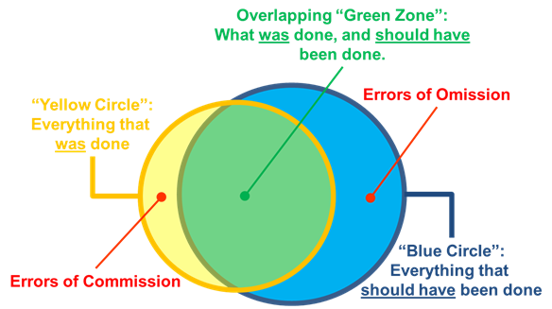

Figure 4 - Care delivery in the GREEN ZONE

5

Some of our existing digital health investments can be leveraged to accelerate the HIE implementation effort.

We can use new, standards-based software “wrappers” (as a façade) to allow us to connect some of our existing legacy solutions into the new HIE. In this way, we will enjoy a “running start” on our project that will accelerate our time-to-value on the HIE implementation project.



Figure 5 - Leveraging legacy solutions as HIE "accelerators"

6

The economics of a shared digital health services model are favourable.

The inherent economies of scale associated with shared services and EMR “platform” approaches yield a favourable return over a 10-year horizon. An investment rationale analysis illustrates the economic value of national-scale investments that address Amalgaland’s key health priorities. A cost-utility analysis (CUA) indicates digital health investments of ~0.85% of total health expenditure (THE) could be cost effective over a 10-year model horizon.



Figure 6 - Money in - Health out (CUA of digital health investments)

7

MOH governance: pooled investments in shared digital services.

The costs of broadly scaled digital health solutions include up-front (one-time) implementation expenses plus ongoing operating and sustaining expenses. To operationalize its digital health strategy, Amalgaland needs to exert governance over development partner funded programmes so that the investment rationale for durable, re-usable infrastructure does not need to be borne by any single (sometimes narrowly focused) initiative. Formerly siloed, programme-based investments should, instead, be reframed as joint investments in cross-cutting, broadly functional shared digital health services that MOH will commit to sustaining post-implementation.



Figure 7 - The importance of MOH governance and coordination

8

The goal is for the national-scale digital health investments to have comprehensive impacts that will systemically improve population health.

The **end goal** of this buildable blueprint is to construct a digitally enabled, cost-effective, interoperable care delivery network that operationalizes guideline-based continuity of care for every Amalgalandian and which generates the management metrics and population health metrics necessary for the MOH to operationalize continuous quality improvement across the care ecosystem. The scope of the blueprint crosses multiple care domains, including primary care, laboratories, pharmacies, and hospitals.



Figure 8 - The "Goal": a systemically improved national health system

## Layout of this document and its sections

This document is prepared in six sections and two appendices:

*[This section is a bulleted list of the blueprint’s chapters. Each chapter heading should be followed by a one-sentence description. As applicable, the following example text should be edited to reflect the present context.]*

* **Introduction**: this section – which includes the purpose and intended audience, key takeaway messages, and the layout of the document.
* **National Burden of Disease**: a high-level summary and analysis of the key burdens of disease in <country> as reported by the Institute for Health Metrics and Evaluation (retrieved: <retrieval date>).
* **National Digital Health Readiness**: a summary of the country’s scoring across the key metrics of the Global Digital Health Monitor (GDHM) and the anticipated implications for the national infrastructure project.
* **National Health and Digital Health Strategies**: a summary overview of the elements of the national health strategy and the national digital health strategy that directly apply to shared infrastructure (the national Health Information Exchange, HIE) and a mapping of key strategic goals to operational workflows.
* **Components of a Health Information Exchange**: a description of architectural actors in a national HIE and the roles they play in operationalizing key workflows. This section articulates a conformance-testable set of national digital health norms and standards.
* **Digital Health Landscape and Quick-win Opportunities**: a high-level overview of existing solutions deployed at scale that can be quickly leveraged to give a “running start” towards a national infrastructure.
* **Digital Health Governance**: a recommended governance structure that may be leveraged to ensure coordination and resource pooling across the various disparate digital health activities. A suggested policy structure is also described that supports national scale health data exchange across both private and public sector care providers.
* **Appendix-1: Example Use Case**: this section provides a worked example of digitally enabled care workflows using *Diabetes* as the target. This example generically references WHO’s recommended care guidelines and maps these guideline-based care pathways to the blueprint’s architectural actors and the care delivery workflows they support.
* **Appendix-2: Exemplar 10-year Digital Health Investment Plan**: this section leverages a digital health investment tool to develop a 10-year cost-utility analysis (CUA). The model’s assumptions are documented, and a sensitivity analysis illustrates the impacts of key implementation-related variables on cost-effectiveness, as measured against the national Cost-effectiveness Threshold (CET).

# Burden of Disease

**Key points:**

Point One…

Point Two…

Point Three…

**Key recommendations:**

Recommendation One

Recommendation Two

*[Begin each section with a summary box. This should be very brief. Resize the box to accommodate your summary points.]*

This section summarizes the country health metrics reported by the Institute for Health Metrics and Evaluation (IHME).[1] IHME is a global repository of health metrics and indicators. It develops and reports metrics based on the country content found at the Global Health Data Exchange.[2] This section includes IHME’s reported country data on demographics, health system operations, and burden of disease.

The following content is from the most recent statistics published by IHME. IHME’s graphics are included in this document without alteration.

*[The following sections cite content from IHME. IHME is treated by World Bank, WHO and others as a* ***trusted source*** *of burden of disease information. As such, it is recommended that the IHME content should appear in the blueprint report, unmodified. TWG members’ inputs and observations related to the IHME data should be faithfully reflected in the* ***Discussion*** *section at the end of the chapter.*

*The content for the following sections is found at* [*https://www.healthdata.org/*](https://www.healthdata.org/)*. Use the* ***Search*** *function to find the* ***country profile*** *for the subject country. For example, the profile for Amalgaland would be found at* [*https://www.healthdata.org/amalgaland*](https://www.healthdata.org/amalgaland)*.*

*NOTE: the purpose of this section of the blueprint is to ground the document in the present realities of the country’s health and demographic context. Information here will provide the supporting data for the investment rationale.]*

## Demographics

*[The demographics data, itself, may be a few years out of date (e.g. for population) so the most up-to-date sources should always be cited. However, the forecast for future population and future population pyramid from IHME should be included, here. Because they are easy to immediately understand, it is suggested to embed the appropriate corresponding graphics for the subject country directly in these sections.]*



Figure 9 – Population Size, current and forecast



Figure 10- Population Age Pyramid, current and forecast



Figure 11 - Life Expectancy, current and forecast

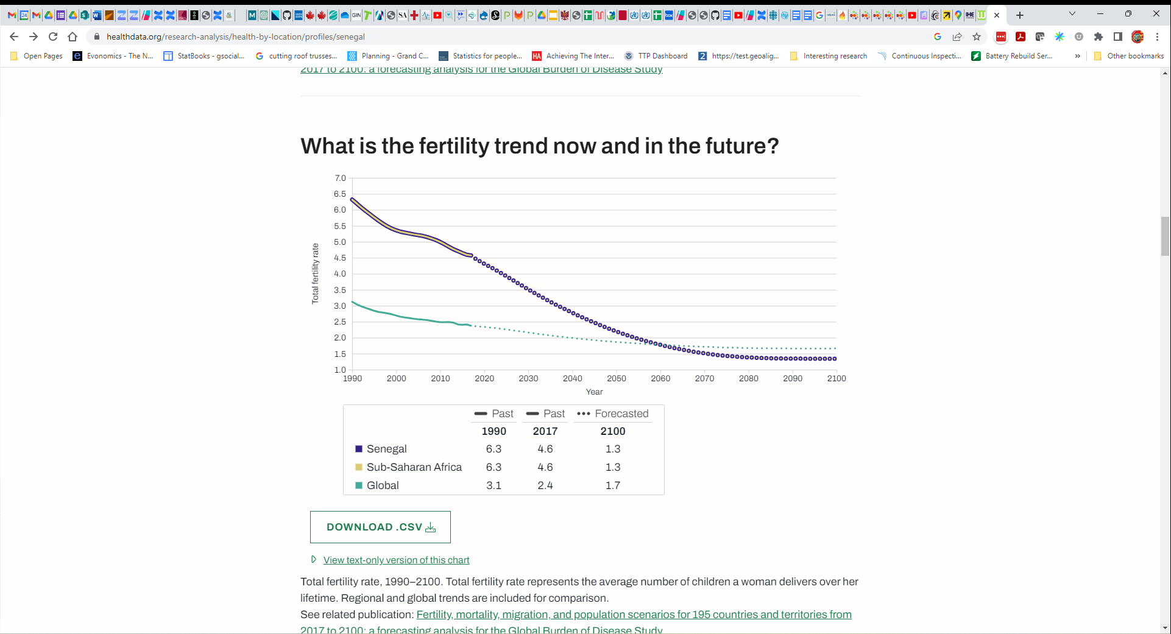

Figure 12 - Fertility, current and forecast

## Health system operations

*[In this section, include IHME information (and maybe graphics) related to expenditures and UHC effective coverage.]*

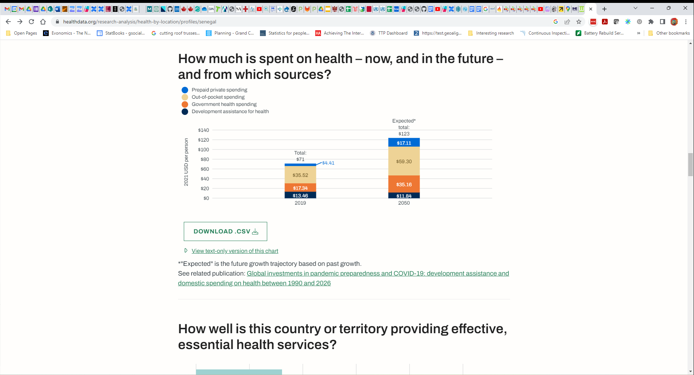

Figure 13 - Health Expenditures by Source, current and forecast

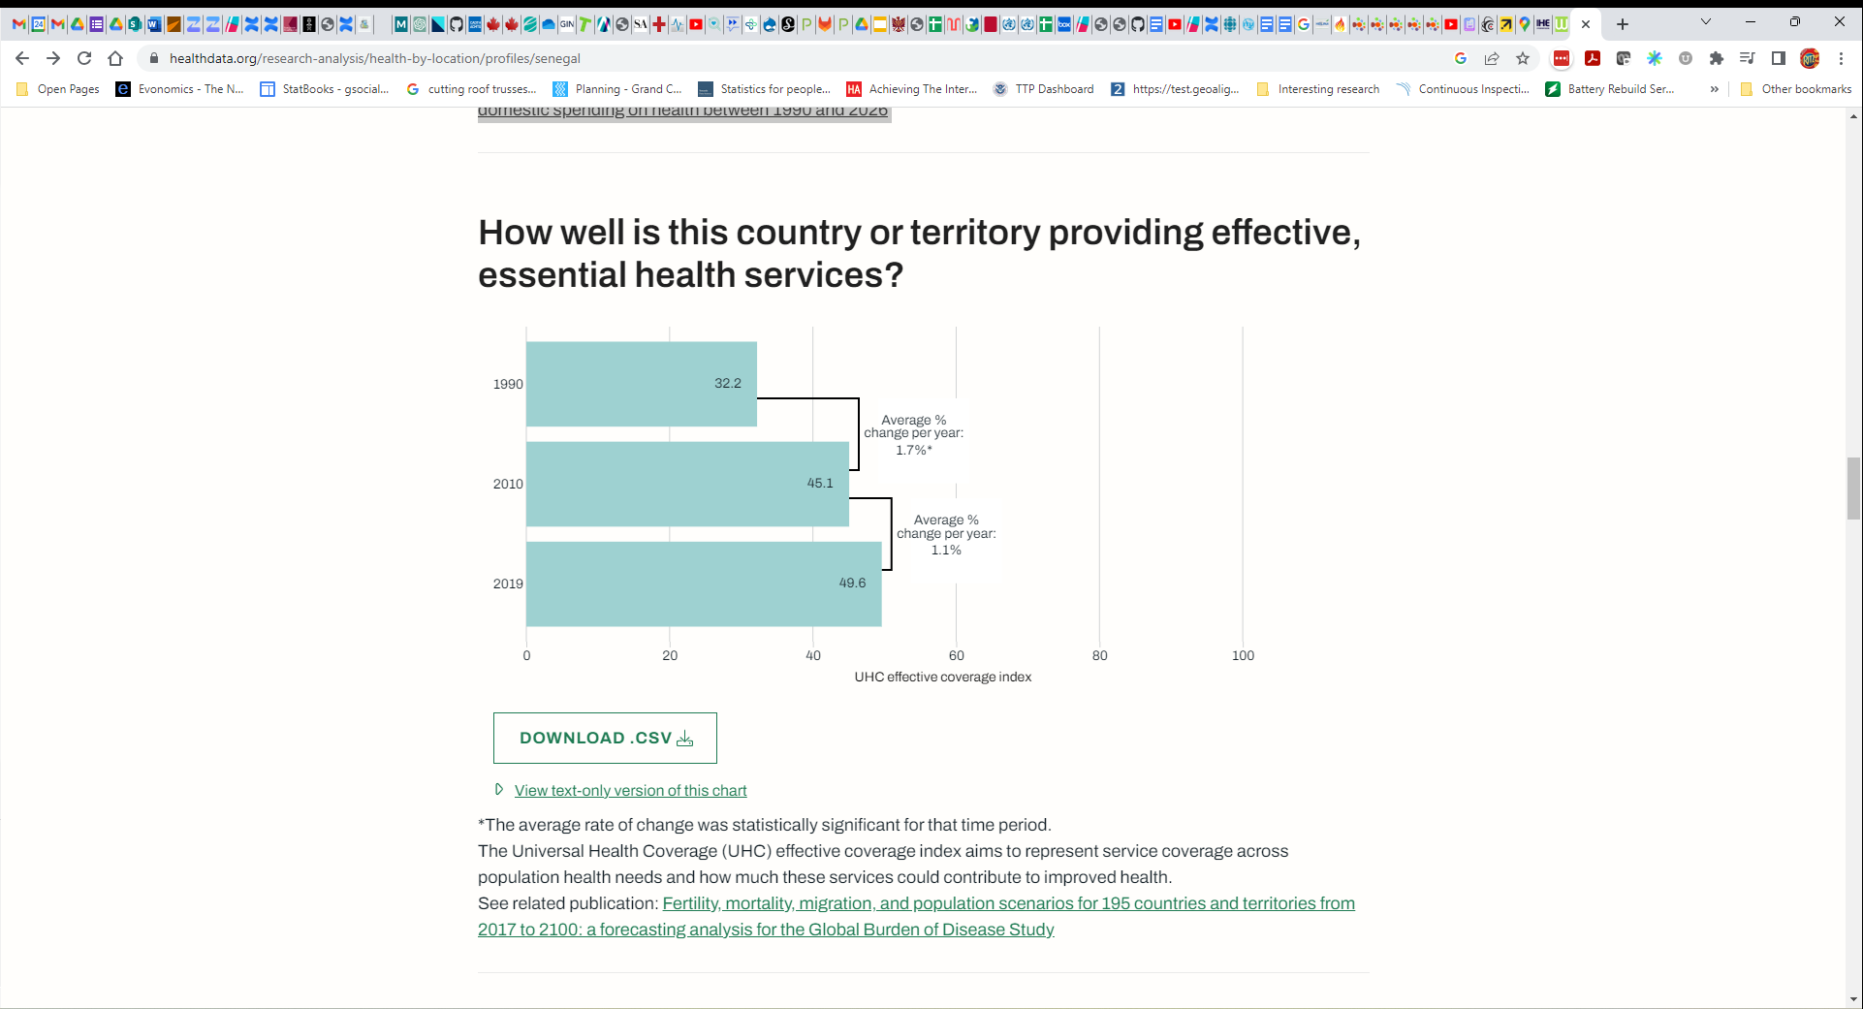

Figure 14 - UHC Effective Coverage

## Burden of disease

*[The causes of death and causes of death and disability combined (burden of disease) are crucial to informing the use cases and the “investment rationale” of the digital health investment plan. The risk factors help identify where digital health can be impactful on this burden. IHME’s information and graphics related to these should be included here.]*

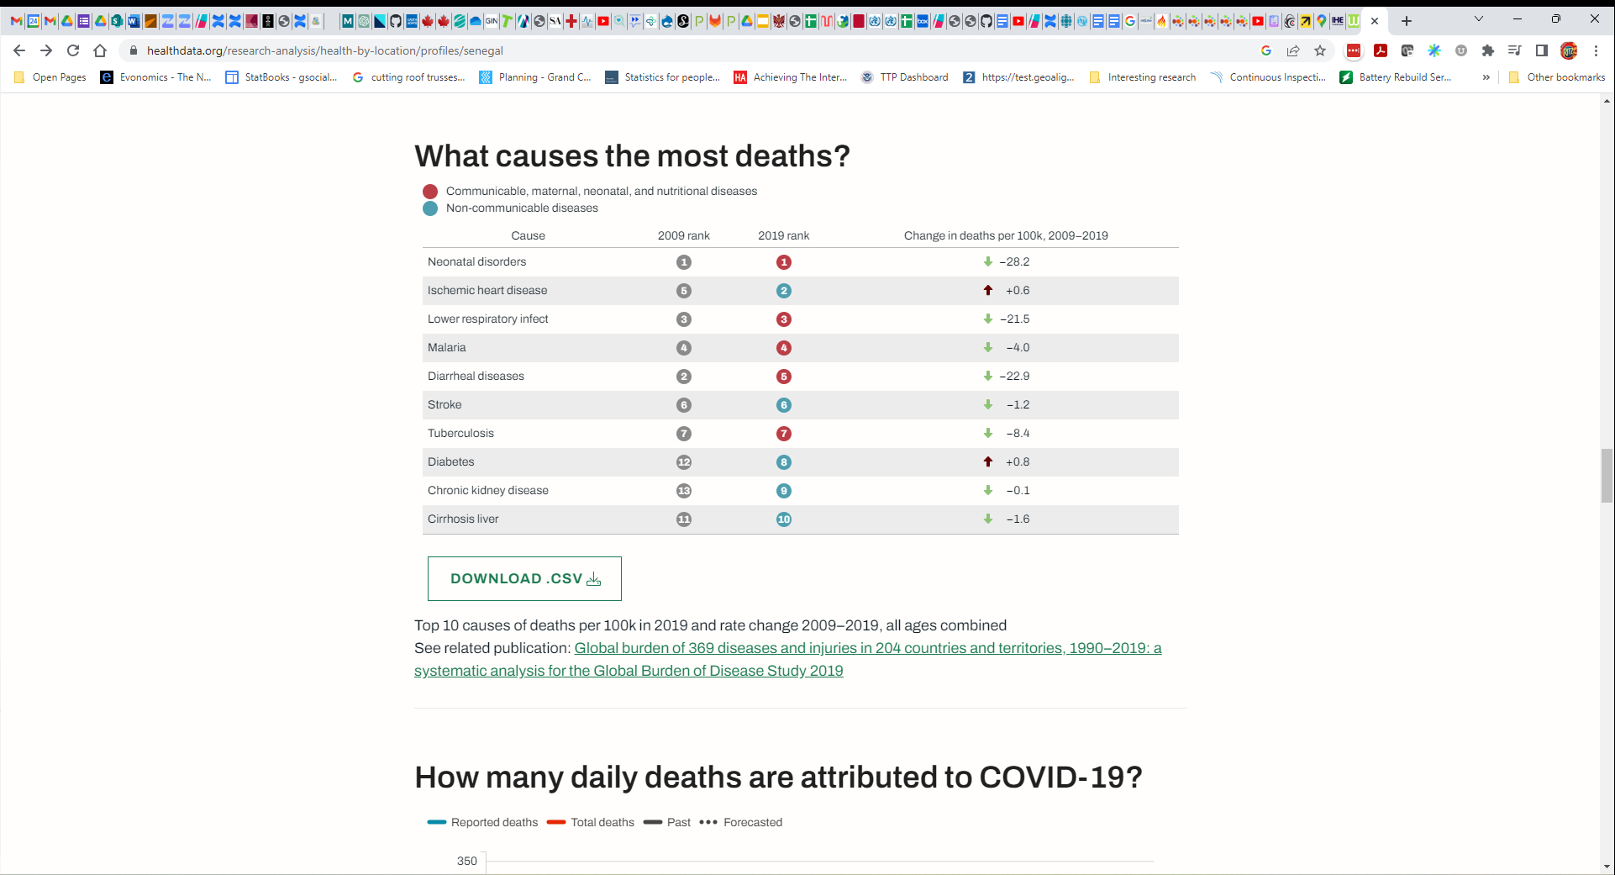

Figure 15 - Causes of Death

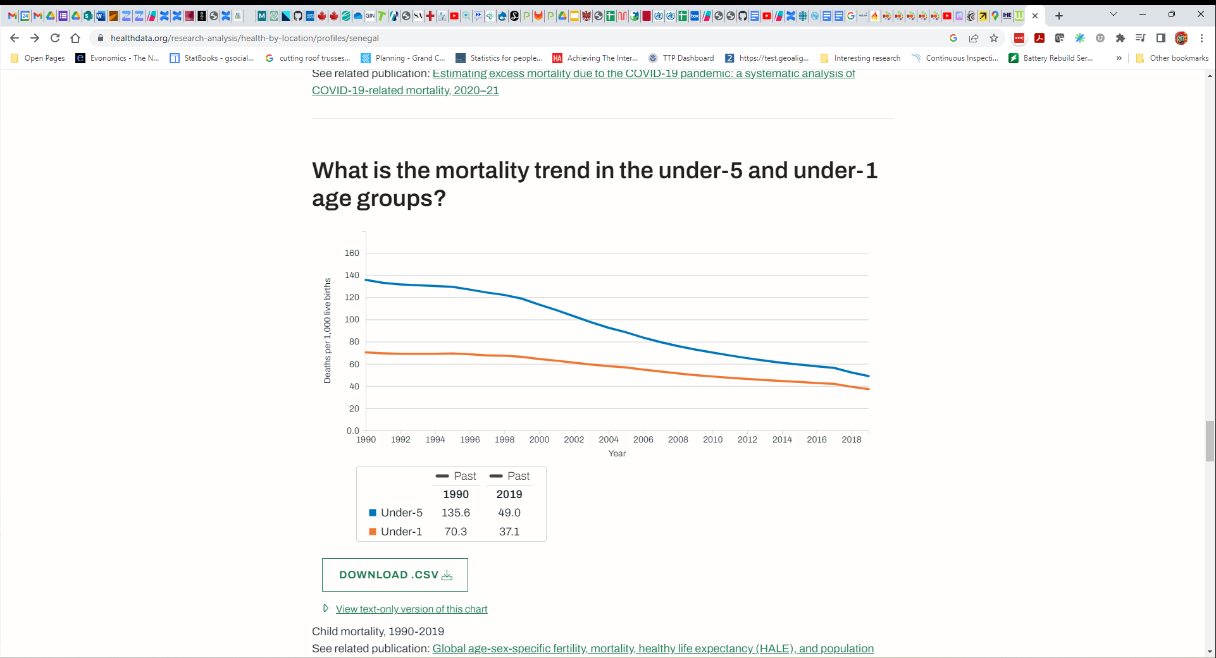

Figure 16 – Child Mortality

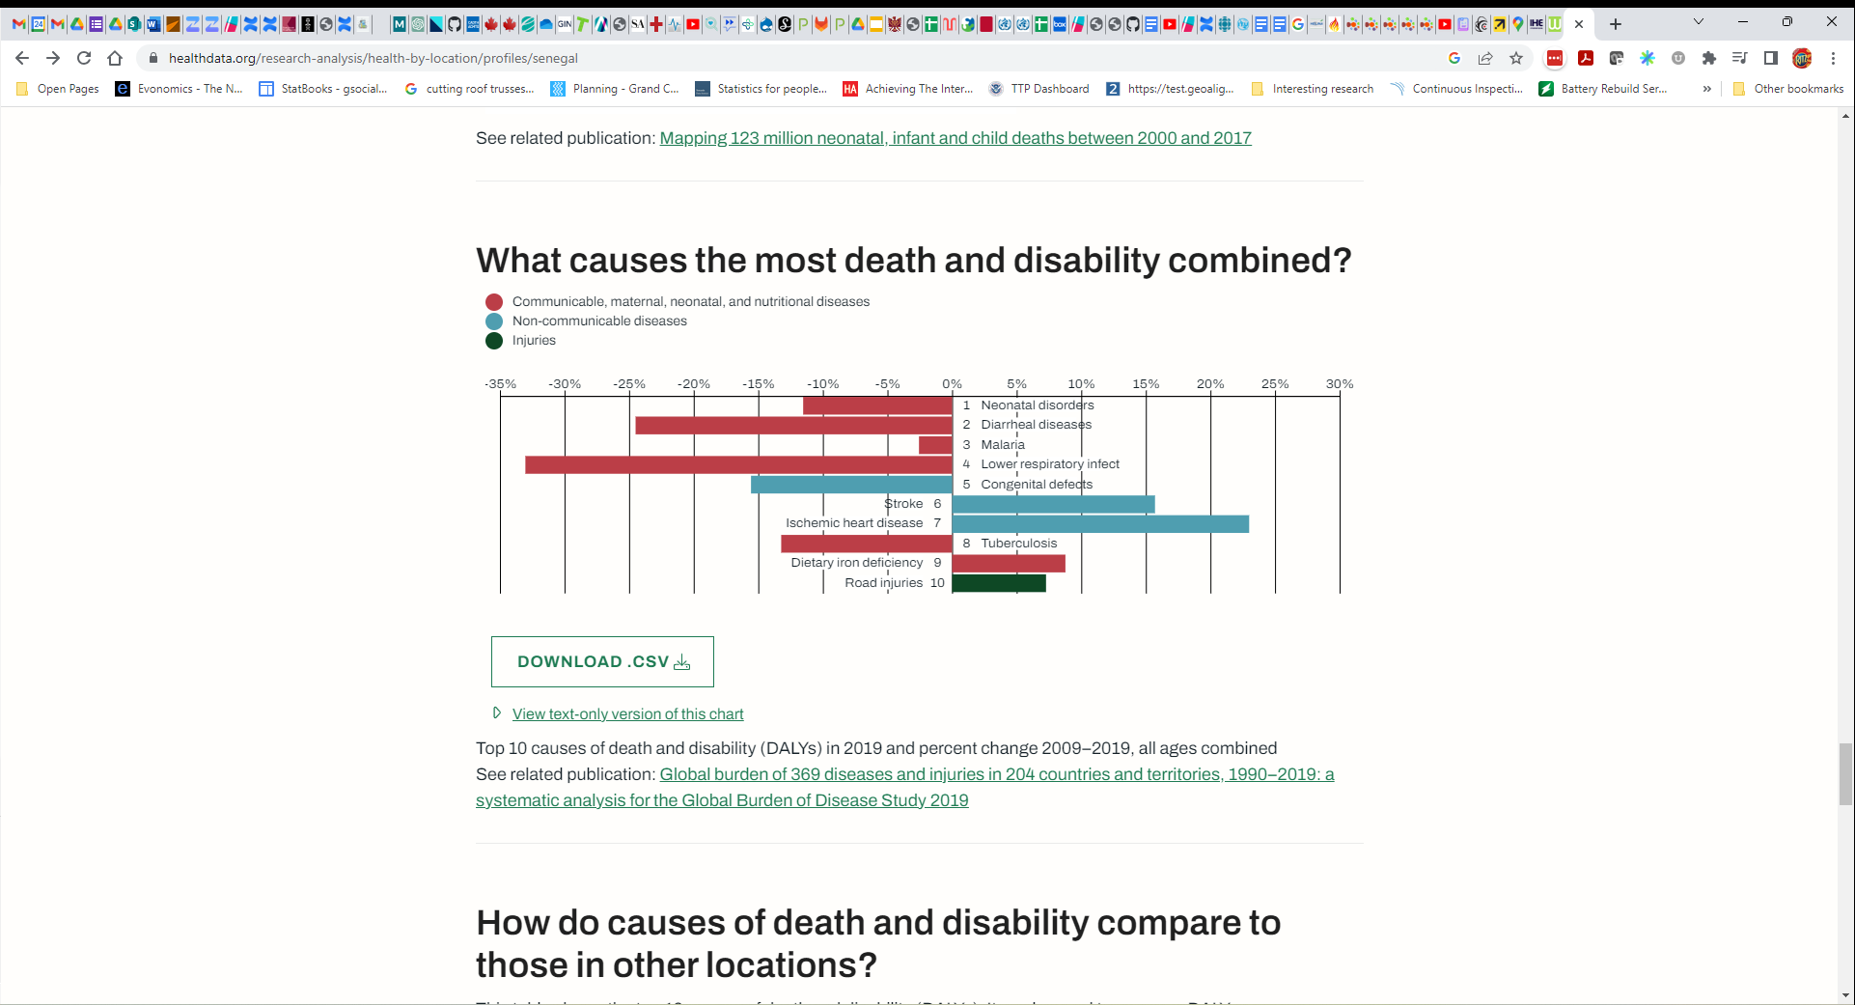

Figure 17 - Top 10 Causes of Death and Disability (DALYs Lost), with 10-year change



Figure 18 - Comparative Burden, vs similar countries

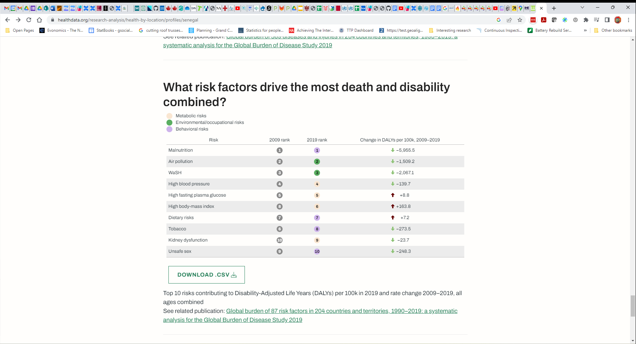

Figure 19 - Top 10 Risk Factors

## Discussion regarding implications of the IHME indicators

*[TWG members’ inputs and observations related to the IHME data should be faithfully reflected in this section. Based on the facilitator’s research, other notes may be called out here, too. These could include, for example, observations related to shifting burden of disease (from infectious to NCD, as an example), or related to life expectancy, or related to forecasts for total health expenditure or of the proportion of out-of-pocket spending vs. government-funded health spending.*

*It is worthwhile, in this section, to make particular note of trends or data that will impact the investment rationale. This includes drawing attention to risk factors that are amenable (or are not amenable) to being impacted by digital health interventions.*

*Because of how important it is later in the investment rationale, it is recommended to prepare a table listing the top-10 DALYs’ causes, and the total disability-adjusted life-years for each. Such content may be obtained from IHME’s GHDx site:* [*https://vizhub.healthdata.org/gbd-results/*](https://vizhub.healthdata.org/gbd-results/)*.*

*It is anticipated that this section will be 1-2 pages long.]*

Amalgaland’s IHME metrics and burden of disease show that the country is on a trajectory similar for others at the country’s socioeconomic status and in their region. The population is growing quickly, but this will taper off in the coming decades as the fertility rate continues to decline. Life expectancy is continuing to rise and, coupled with the slowing fertility rate, the country is projected (in 2100) to find itself with the large proportion of elderly citizens commonly found, today, in many OECD countries.

Amalgaland’s 2019 total health expenditures were **$71 USD per capita**; the largest proportion of these were out-of-pocket expenses. Expenditures are projected to rise over the coming three decades, but without a fundamental reframing of health system finances, the out-of-pocket proportion will not be replaced by insurance-based funding. Although the national UHC index rating has increased from 32.2 to 49.6 over the period 1990 to 2019 – this is still indicative of the need for more progress regarding UHC.

Progress continues to be made in addressing under-5 and infant mortality rates (note Figure 16). As may be noted from Figure 15, however, the top-10 causes of death in Amalgaland include five non-communicable diseases (**NCDs**) and for two of these, the rate of deaths per 100k population is increasing (ischemic heart disease, and diabetes). This reflects the ongoing shift in Amalgaland’s burden of disease from infectious to non-communicable diseases as the economy strengthens and as programmes to address Malaria, TB and HIV continue to have a mitigating impact.

From Figure 17 it is evident that the burden of disability-adjusted life years (DALYs – which measure the health impacts of both mortality **plus** morbidity) from most infectious diseases continues to decline while the health impact from NCDs is on the rise. At present, ischemic heart disease (+23%) and stroke (+16%) represent the most rapidly increasing DALY burden over the 10 years 2009-2019, and are quantitatively the 7th and 6th largest DALY burdens, respectively. The IHME metrics identify increasing risk factors (Figure 19) related to diet (+7.2%), obesity (+164%), and with these two, increasing rates of unhealthy blood glucose levels (up by 8.8% during the period 2009-2019).

Many TWG members expressed surprise at the IHME metrics and at how quickly the burden of disease is shifting. Indicative of the need to address the present concerns (infectious diseases) as well as the future concerns (NCDs), there emerged a consensus within the TWG around using **malaria** and **ischemic heart disease** as two “cardinal” use cases. This is not at all to suggest that these would be the only use cases supported by the HIE – rather that the evidence-based care workflows for these two use cases would drive the acceptance-testing of the HIE design.

As a corollary to the expectation that the HIE can improve guideline-adherent care workflows, the TWG members identified **care quality** and population **health outcomes** as two priority health system management indicators. This supports a theory of impact that proposes the investments in digital health, at national scale, will help **systemically improve care guideline adherence** and that this improvement will lead to **measurably improved health outcomes**.

# Digital Health Readiness

**Key points:**

Point One…

Point Two…

Point Three…

**Key recommendations:**

Recommendation One

Recommendation Two

*[Begin each section with a summary box. This should be very brief. Resize the box to accommodate your summary points.]*

This section summarizes the country’s readiness scores across the different axes of the Global Digital Health Monitor.[3] An overall digital health readiness score is reported as well as individual metrics related to:

* Leadership & Governance
* Strategy & Investment
* Legislation, Policy, & Compliance
* Workforce
* Standards & Interoperability
* Infrastructure
* Services & Applications.

As noted on their website, “[t]he Global Digital Health Monitor (GDHM) is an interactive web-based resource that aims to track, monitor, and assess the enabling environment for digital health throughout the world.”

The following content is from the most recent survey results from the GDHM site augmented by insights from the relevant TWG workshops.

*[The following sections cite content from GDHM. GDHM is treated by World Bank, WHO and others as a* ***trusted source*** *of digital health readiness assessment. As such, it is recommended that the GDHM content should appear in the blueprint report, unmodified. TWG members’ inputs and observations related to the GDHM data should be faithfully reflected in the* ***Discussion*** *section at the end of the chapter.*

*NOTE: if there is no GDHM content for the country, or if the content is woefully out of date, then the GDHM Google Form survey responses may be employed in this section – with a clear notation that these “TWG” data are being reported.*

*The purpose of this section of the blueprint is to further ground the document in the present realities of the country’s context. Information here will provide supporting data for the investment rationale and, importantly, the level of effort and time needed to roll out a national implementation.]*

## GDHM Overview

*[On the GDHM country website page, select an appropriate regional comparator. As an example, for a sub-Saharan country, choose “Africa Region” in the “Compare to” drop-down box. Capture (copy) the “spider graph” that illustrates the GDHM score and the comparator score for each metric. It is also recommended to capture the Context, Health, and Country Summary information and to faithfully include it in this section. Note the country’s* ***overall*** *score.*

*NOTE: if the GDHM Google Form was employed, leverage the Toolkit’s* ***GDHM spider graph*** *spreadsheet to create the necessary graphic and include the graphic, only, in this section.]*



Figure 20 - Amalgaland's GDHM Summary

## Leadership & Governance

*[Capture (copy) content from the relevant GDHM section and paste it here. Provide a short narrative comment regarding what are the likely implications of the reported phase-level.]*

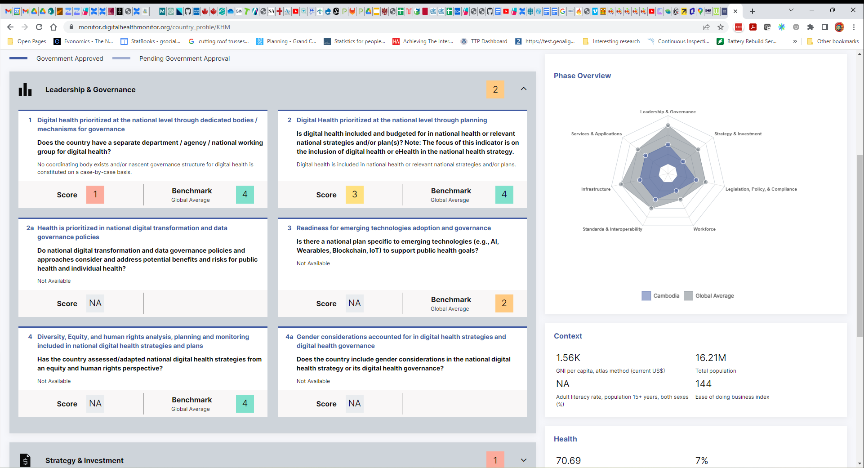

Figure 21 - GDHM Leadership & Governance

## Strategy & Investment

*[Capture (copy) content from the relevant GDHM section and paste it here. Provide a short narrative comment regarding what are the likely implications of the reported phase-level.]*

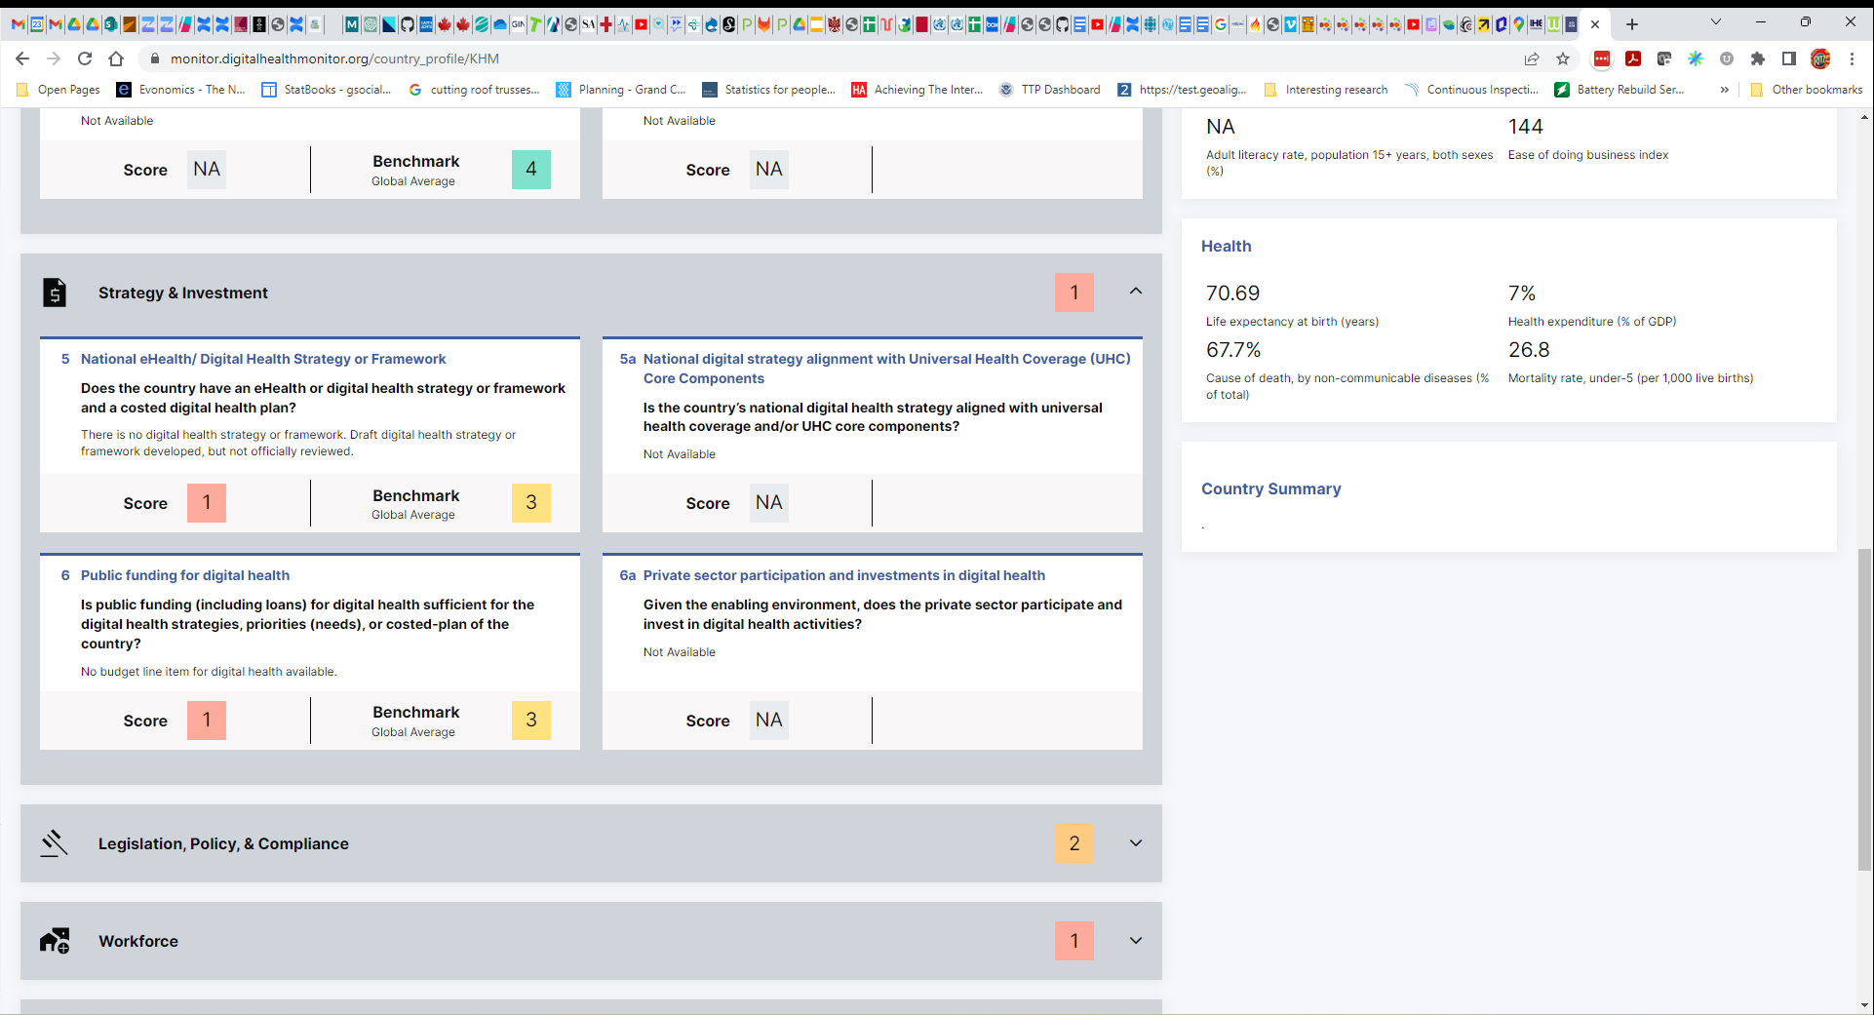

Figure 22 - GDHM Strategy & Investment

## Legislation, Policy, & Compliance

*[Capture (copy) content from the relevant GDHM section and paste it here. Provide a short narrative comment regarding what are the likely implications of the reported phase-level.]*

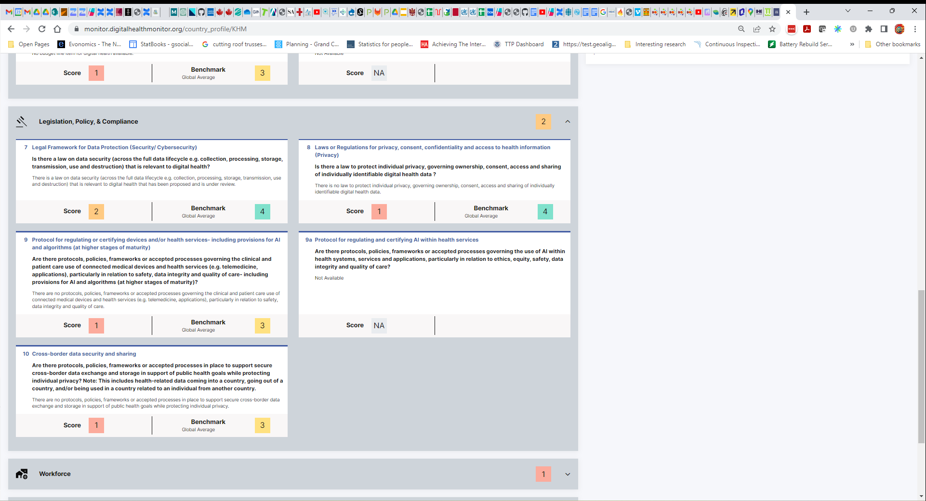

Figure 23 - GDHM Legislation, Policy, & Compliance

## Workforce

*[Capture (copy) content from the relevant GDHM section and paste it here. Provide a short narrative comment regarding what are the likely implications of the reported phase-level.]*

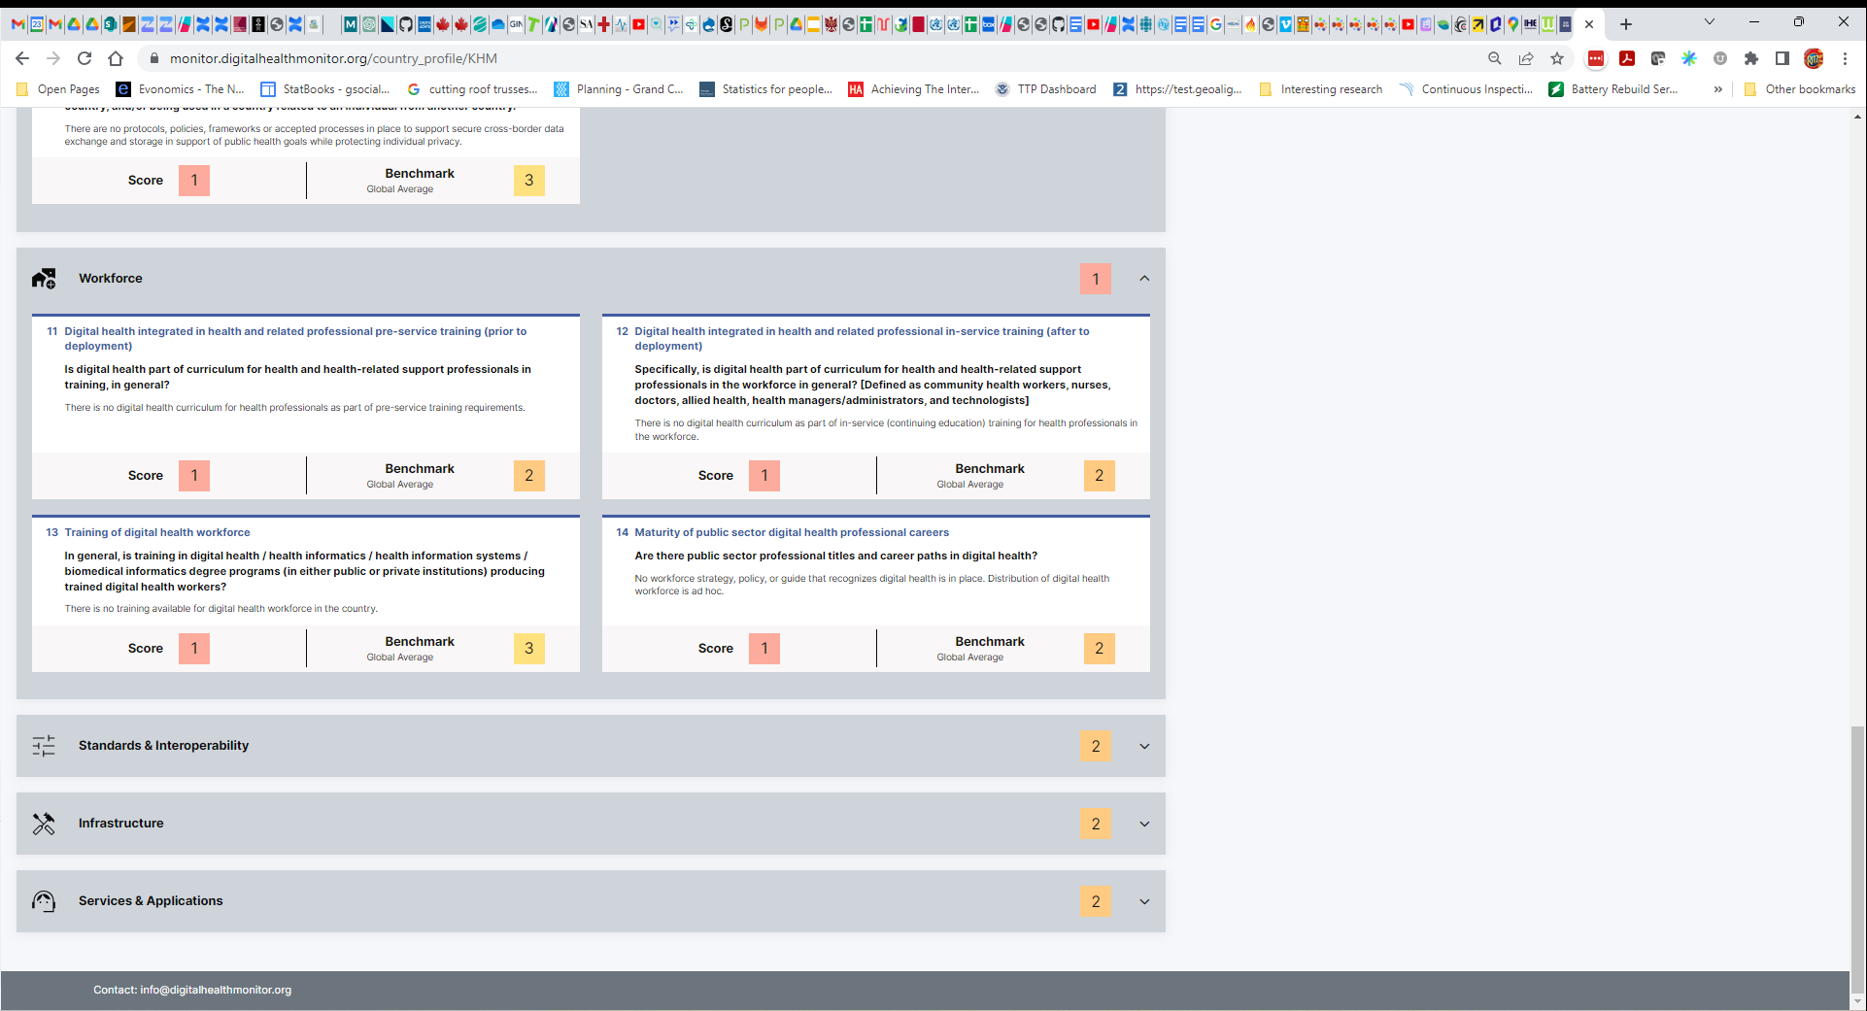

Figure 24 - GDHM Workforce

## Standards & Interoperability and Infrastructure

*[Capture (copy) content from the relevant GDHM section and paste it here. Provide a short narrative comment regarding what are the likely implications of the reported phase-level.]*

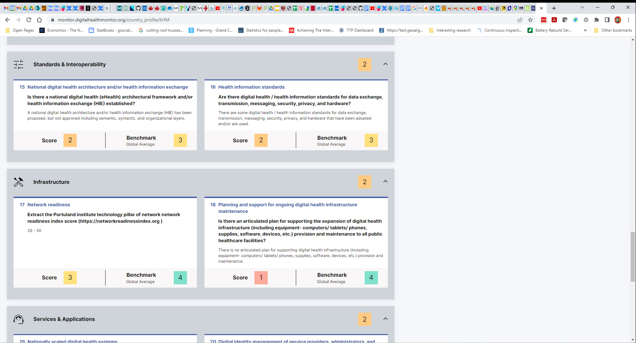

Figure 25 - Standards & Interoperability and Infrastructure



Figure 26 - Mobile Network Coverage (MTN)



Figure 27 - Mobile Network Coverage (kt)

## Services & Applications

*[Capture (copy) content from the relevant GDHM section and paste it here. Provide a short narrative comment regarding what are the likely implications of the reported phase-level.]*

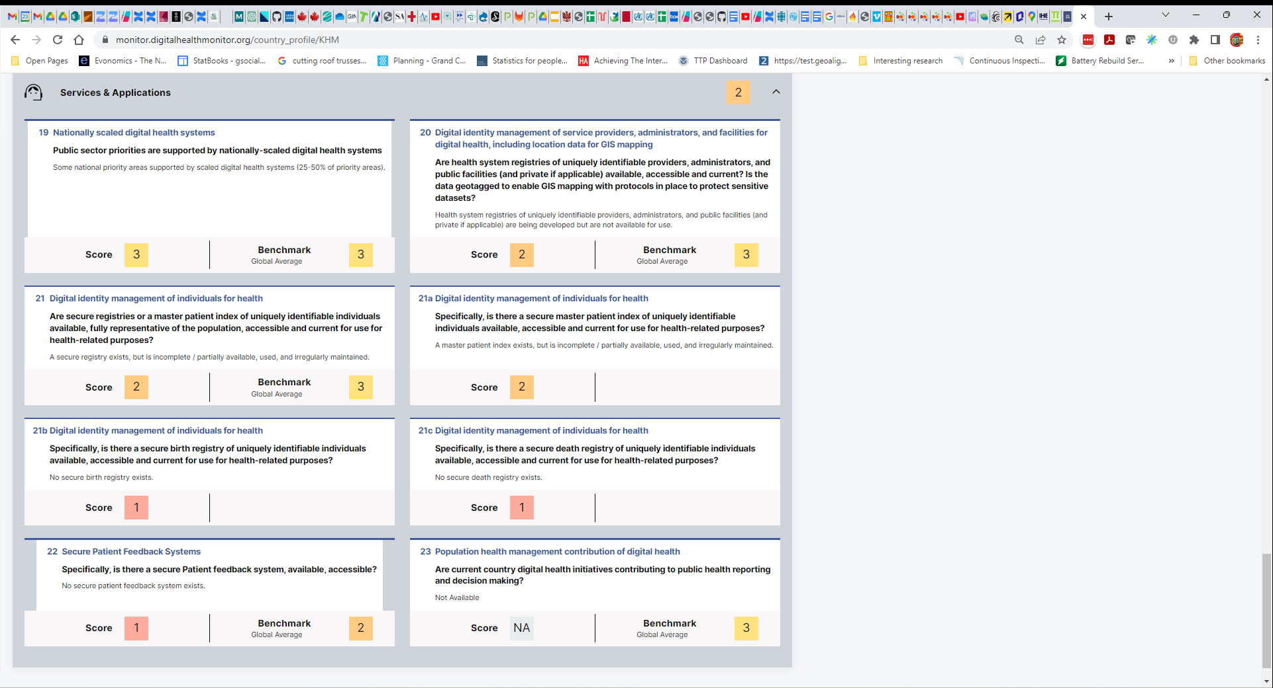

Figure 28 - Services & Applications

## Discussion and Implications of the GDHM indicators

*[Here is the place to draw an overarching summarization of the country’s digital health readiness. Provide narrative comments and relevant* ***TWG inputs*** *that speak to the likely implications of the reported phase-level. Address questions like: where will we need to make extra investments (e.g. governance? infrastructure? etc.) what will be the implications on our pace of deployment? (we can go fast… we will be limited to the pace of mobile phone adoption, etc.)]*

The following may be summarized as the key takeaway points related to digital health readiness:

* Amalgaland’s digital readiness is lower than the global average across ***every*** axes and most notably lower for the metrics related to:
  + Leadership & Governance,
  + Strategy & Investment, and
  + Infrastructure.
* There is ***good*** network availability across all main population centres, including strong available of internet-capable (3G and higher) connectivity.

# National Health and Digital Health Strategies

**Key points:**

Point One…

Point Two…

Point Three…

**Key recommendations:**

Recommendation One

Recommendation Two

This section summarizes the country’s current health and digital health strategies and documents their alignment to the burden of disease, and to each other.

*[The following sections cite content from the country’s* ***health strategy*** *(most recent version) and* ***digital health strategy*** *(most recent version). If these documents are not current enough to be relevant to the present blueprint, then consensus information collected during the facilitated workshops will be cited, instead, in the blueprint document.]*

## Overview and background

*[This section should faithfully document details that were used as* ***inputs*** *to the TWG workshops. The publication date or version of each document should be noted. Overview narrative from the* ***Executive Summary*** *sections of the health strategy and digital health strategy should be cited, here – including* ***relevant graphics*** *that give a big-picture view of each strategy and its key focus areas.*

*The summary information should include elements such as: (1) key target care delivery* ***programmes*** *identified and health improvement targets (where applicable); (2) care* ***network design*** *changes, if applicable, such as consolidation of or devolving of funding and/or responsibilities; (3) relevant* ***data reporting*** *requirements; (4)* ***UHC-focused initiatives*** *and their target timelines; (5) health* ***enterprise architecture*** *choices, if relevant (e.g. has OpenHIE been adopted… has FHIR been adopted… etc.); (6) key digital health* ***product*** *choices that have been made (e.g. DHIS2… HAPI FHIR… etc.).*

*Where relevant, it may be useful to frame elements of the strategy in terms of the* ***WHO-ITU National eHealth Strategy Toolkit*** *(2012).[4]*

*This “Overview and background” section should not exceed 4-5 pages.]*

The Amalgaland Health Sector Strategic Plan 2018-2023 was leveraged as a framing document for the blueprint project. Alongside the National Digital Health Strategy (NDHS), the blueprint goals and target use cases were informed by these documents.



Figure 29 - Health Strategic Plan Conceptual Framework

As noted in Figure 29, the strategic plan is supporting, as its ultimate goal, improved UHC for the country. The HIE initiative can be framed as one of the key enabling environments (right-hand side of the graphic) that will support improved quality of care leading to effective coverage and better health outcomes for all.

Quoted from page 37 of the Health Strategic Plan:

*Communication and the transfer of health information is key to the delivery of sustainable high-quality health care. Health care and ICT are slowly becoming more interconnected in the country thanks to the comprehensive National e-Health Policy. In this context, communication services and facilities include telemedicine, mobile-health, e-learning, telephone connections, Internet services, intercom or public address systems, local area networks and computers with the necessary accessories.*

*Some positive developments in ICT technology that need to be pursued under the new strategic plan are:*

*a. Automation, which has improved access to information and reduced information transmission time for medical decision-making;*

*b. Improvements in procurement logistics through the online requisition of commodities, thus reducing order turnaround time;*

*c. Automation of laboratory equipment, which has reduced workload and error margins, resulting in more accurate diagnoses and improved patient outcomes.*

*ICT is also part of health-sector norms and standards, but, on average, counties have only 50 per cent of the required communication equipment (see figure 2.17). As at 2018, the least-equipped county, at 5 per cent, was Region-1 and the best-equipped, at 88 per cent, was Region-2. Counties averaged at 31 per cent in terms of equipping with computers with Internet access, with the least-equipped being County-1 at 5 per cent, and the best equipped being County-2, at 77 per cent (Ministry of Health, 2018f).*

*There is need to improve Internet coverage and access to communication equipment. The investment plan for the health factor lacks clear articulation of ICT requirements in the health sector, resulting in inadequate funding and suboptimal ICT infrastructure. Collaboration and planning among agencies dealing with ICT infrastructure should also be enhanced.*

The main challenges noted in the Strategic Plan (page 43) are:

*• Inadequate capacity for analysis and the development of targeted dissemination products*

*• Lack of attention to analysis and the use of information for decision-making*

*• The existence of multiple unlinked databases*

*• Inadequate use of ICT and poor investment in e-health and other technologies*

*• Inadequate resources.*

A set of clear targets are articulated by the Strategic Plan (page50). These are noted in Figure 30. These ambitious targets speak to the government’s desire to improve longevity and improve **quality** of life by both reducing mortality and reducing morbidity.



Figure 30 - Health Strategic Plan TARGETS

The Health Strategic Plan explicitly references the NDHS (page 72) and calls out for key areas for action, including:

*• Enhanced multisectoral planning regarding ICT infrastructure;*

*• Development of ICT guidelines and deployment infrastructure in all levels of care;*

*• Mobilization and allocation of adequate resources for the procurement and maintenance of ICT equipment and infrastructure;*

*• Adoption of modern technology that enables patients to conduct crucial tests themselves, send the results directly to a medical practitioner and receive a response via the Internet;*

*• Development and strengthening of mechanisms for reporting adverse incidents relating to medical devices.*

The Health Strategic Plan explicitly calls (page 78) for “*Establishment of a Kenya Health Information Exchange platform and development of guidelines to address issues of interoperability and information exchange*”. The NDHS builds upon the Strategic Plan’s high-level action areas and outlines a fulsome policy plan for how the HIE initiative can be progressed. NDHS (page 18) articulates the policy priority related to foundations of ehealth infrastructure:

*To establish the technical foundations for the eHealth infrastructure and resources, the government through the Ministry of Health shall oversee implementation of the following interventions:*

*1. Develop* ***a national enterprise health systems architecture*** *as a blueprint for design and implementation of eHealth systems;*

*2. Provide guidelines to ensure deployment of appropriate hardware, software and network technologies;*

*3. Ensure deployment of qualified human resources capable of developing, implementing and maintaining eHealth systems.*

*4. Develop* ***standard operational guidelines*** *on development, hosting and secure use of* ***cloud-based eHealth services and applications****.*

Section 4.3.3 (page 18) of NDHS describes the OpenHIE-based HIE architecture that will be operationalized, as follows:

*Interoperability is the ability of an electronic system to communicate and exchange data in an accurate, reliable, and meaningful way with another information system so that the operational purpose and meaning of the data are preserved and unaltered.*

*This policy also recognizes the need for shared health records though development of Client Registry (CR) that encompasses National Unique Patient Identifier (NUPI), Master Patient Index (MPI), Terminology Service (TS), Health Information Exchange (HIE), and Personal Health Record (PHR). This unified approach will ensure that health data is available regardless of differences in architecture, service providers, technology used or locality. All eHealth systems implemented in the health sector shall be linked with the existing Data Aggregators like DHIS2, Integrated Human Resource Information System (iHRMIS), and Logistics Management Information Systems (LMIS). The integration will create a central health data repository shared by health institutions.*

*To realize full integration and interoperability, the government will be required to collaborate with Standards Development Organizations (SDOs) to develop or identify appropriate standards for secure communication, networking, and processing of clinical documents.*

Based on its assessment of the present context, the TWG is confident that the proposed standards-based, cloud-hosted, OpenHIE-conformant HIE approach is consistent with Amalgaland’s published health strategy and digital health strategy artefacts.

## Discussion related to the country’s strategic plans

*[This section should reflect discussion that arose from the* ***facilitated TWG workshop*** *related to the country’s strategic plans. The section should include* ***graphics*** *depicting results from workshop’s the real-time questionnaires. Particular note should be made of areas where there are* ***mismatches or misalignments*** *between the health and digital health strategies or where either (or both) appear to be misaligned to the country’s present burden of disease.*

*In cases where either strategy document may be considered* ***out of date*** *– this section can be leveraged to document TWG consensus on what present context should drive the content of the buildable blueprint. If there has not yet been an opportunity to refresh the strategies to reflect* ***impacts of the pandemic****, this section can also be employed to document new realities that should be addressed by the blueprint.*

*This discussion section should not exceed 2-3 pages.]*

It was a consensus view of the TWG that both the health strategy and digital health strategy should be updated on a 4-5 year cycle. This has a practical implication that both the cited strategies should likely be reviewed and refreshed in the coming year. Notwithstanding this, it is the view of the TWG that both of these documents are consistent with each other and with Amalgaland’s present (and evolving) burden of disease. There was a clear consensus that the national HIE would play an essential role in supporting the country’s health system goals of improved care quality and access on the road to furthering UHC in Amalgaland. There was an equally strong consensus that the HIE would well address the country’s burden of disease, now and in the future.

There was particular focus, during the TWG’s workshops, on the ways the WHO’s SMART Guidelines initiative could have a positive impact. This innovative use of digital health to foundationally improve care quality is one of the reasons why a strategy refresh would be well advised. At present, the TWG believes only a small proportion (well less than half) of existing legacy digital health solutions are ready to operationalize computable care guidelines (CCGs) such as the WHO SMART Guidelines. Furthermore, the TWG believes it will likely take 3-4 years for the preponderance of digital health solutions to be ready to implement CCGs. Even so – a CCG initiative is contemplated in the design and will be well supported by the HIE investments. It is felt that CCG adoption could be strategically impactful for Amalgaland.

## Mapping strategic goals to HIE design specifications

*[This section should call out specific areas of the strategic plans that will rely on the successful deployment, at scale, of elements of the buildable blueprint. The narrative in this section serves as an introduction to the technical design elements in the following section and gives an overview of their “role” in satisfying the “business needs” articulated by the strategies.*

*The narrative in this section could call out strategic elements, for example, related to offering insured services to citizens – and map these to the need for a demographic database (a client registry) and the unique IDs (e.g. health cards) that may be needed to operationalize insured, person-centred care. Likewise, goals related to improved disease surveillance could be mapped to data content models and coding schemes that will be needed in order for reportable health events to be collected into meaningful statistics. These are just examples; the map will depend upon what is in the relevant country strategies.*

*This mapping section should not exceed 1-2 pages.]*

Amalgaland’s key strategic goals are supported by the proposed HIE (details of which are described in the following section). A narrative description of this blueprint’s functional footprint, follows:

* Standards-conformant point of service (POS) solutions will be able to leverage the HIE to: resolve unique patient IDs, retrieve patient-centric health summary documents, execute guideline-based care encounter workflows, and update the HIE with the results of the care encounters, including an updated health summary.
* An approach based on software façades is described which will allow key legacy infrastructure applications, such as DHIS2, and key POS solutions (such as E-Heza, and ANC CCG Module, and Umurinzi) to be quickly onboarded to the national HIE.
* Mandatory, conformance-testable POS behaviours of “good HIE citizens” are described.
* A national client registry (CR) with standards-based interfaces based on the HL7 FHIR specification will be operationalized and opportunistically “seeded” with the de-duplicated records from the national COVID registry.
* The DHIS2-based HMIS will support aggregate indicator reporting workflows (manual and *automated*), health system management analyses, and GIS capabilities.
* The HIMS (as an HIE actor) will be able to act as an underlying directory to a national Facility Registry (FR) and the national Organization Registry (ORG). The FR and ORG will operate within the context of a standards-conformant Interlinked Registry (ILR) that cross references facility, organizational, provider, and health services identifiers and records.
* As noted above, the ILR will support Health Worker Registry (HWR) functionality and leverage underlying human resource directories (such as payroll systems) to feed it the raw content using the supported standards-conformant transactions.
* A standards-conformant terminology service (TS) will act as a repository and database of code lists. These will be cross-referenced by the ILR and will be downloaded, on a regular basis, by POS solutions that will be expected to abide them during transaction processing interactions with the HIE. To defend online transaction processing performance, the TS will **not** participate in real-time transactions.

# Components of a “buildable” Health Information Exchange

**Key points:**

Point One…

Point Two…

Point Three…

**Key recommendations:**

Recommendation One

Recommendation Two

This section describes the building blocks of a national health enterprise architecture and how these building blocks may be leveraged to construct a working health information exchange (HIE).

*[This section describes the elements of an* ***OpenHIE-on-FHIR*** *based health enterprise architecture. The transaction-processing behaviours of each architectural “actor” are defined in terms of conformance-testable* ***IHE Profiles****. The person-centric health data model is based on the FHIR-based* ***International Patient Summary (IPS)*** *implementation guide (IG).*

*It is the intent of this “buildable blueprint” to leverage existing, widely adopted, conformance-testable norms and standards. These standards (and the OpenHIE architecture) are supported by WHO as the foundation of its digital health strategy. The assumption, therefore, for this toolkit is that the TWG will* ***adopt existing specifications*** *to the fullest extent possible; it will adapt these specifications where necessary; and only as a last resort will net-new specifications need to be developed from scratch.]*

## Overview and background

*[This section provides a technical description of the OpenHIE-on-FHIR actors and the transactions each actor executes in service of a national HIE. Each HIE building block is described at a top level and the way they fit together is illustrated. The design depicted in this section assumes a cloud hosted infrastructure that operationalizes high-performing FHIR Services.]*



Figure 31 - OpenHIE Blueprint (health-related actors)

The buildable blueprint design leverages an existing, “off the shelf”, set of digital health **architectural** specifications as generally defined in the OpenHIE[5] framework. The OpenHIE Architecture diagram is shown in Figure 31. To bring the blueprint to life, its care delivery workflows are mapped to a set of implementable, standards-based, interoperability specifications as defined by the IHE Mobile Health Document Sharing (**MHDS**) Profile[6]. A set of architectural “actors” relevant to an OpenHIE-conformant HIE are listed in Table 1. An engineering diagram depicting how an OpenHIE-based architecture could be operationalized in a cloud-hosted infrastructure is illustrated in Figure 32.

|  |  |
| --- | --- |
| * **TS\***: a terminology server that supports ontology mapping and code list publishing * **CR\***: a standalone client registry that supports patient record matching and de-duplication * **CR* POS**: a client application that supports the “ceremony” of adding a new demographic record to the HIE (e.g. ID card printing, etc.) * **POS Solution**: point of service digital health application (e.g. Electronic Medical Records (EMR), Lab Information System (LIS), Community Health Worker app, etc.) * **CCG Engine**: computable care guidelines processor * **Interoperability Layer**: enterprise shared service bus | * **CR**: runtime client registry service * **ILR/TS:** runtime terminology service, including interlinked health service codes * **ILR-HWR:** runtime interlinked health worker registry * **ILR-FR:** runtime interlinked facility registry * **ILR-ORG**: runtime interlinked organization registry * **SHR**: shared health record repository * **HMIS**: health management information system, including a data analytics engine * **HWD**: federation of health worker directories * **FD**: federation of facility directories * **ORG**: federation of organization directories * **ATNA**: audit trail and node authentication services |

Table 1 - Digital health infrastructure actors



Figure 32 – Functional Capability of a Cloud-hosted OpenHIE-based architecture

As may be noted from the diagram, it is anticipated that the national HIE will be cloud hosted. To defend online transaction processing (OLTP) performance, computationally “expensive” services such as terminology mapping and publishing, client record creation and management (e.g. de-duplication), and analytic processing (e.g. HMIS) will be architecturally separated from the OLTP-optimized FHIR Services. It is also expected that the interlinked registry (ILR) of health workers, facilities, organizations, and health services will be refreshed from an underlying federation of directories as part of a regular maintenance cycle. As an example, extracts from the membership databases of the College of Nurses, College of Physicians, College of Pharmacists, etc. will be regularly updated to the OLTP FHIR Server’s interlinked registries as part of a managed batch update process.

The following list outlines the HIE’s transactional functionality as depicted in Figure 32. Transactions supporting maintenance processes are identified in blue; real-time processes are shown as yellow.

1. **Terminology Publishing**. A terminology server (TS*) will be employed to curate and cross reference the national lists of normative codes. As part of a regular refresh process, the MOH will publish updated code lists and make these available so that digital health POS solutions can update their code lists. This is illustrated by transaction (1). As shown by transaction (2), these published terminologies will also update the runtime code lists maintained in the OLTP-optimized FHIR Server. NOTE: it is common for such publishing processes to employ Excel and/or PDF files as the means of distributing code lists. Each POS solution will be required to be able to ingest the published format. The interactions with the TS* *may* be managed via the Interoperability Layer.
2. **Manage Client Registry Records.** It is expected that there may be a *ceremony* associated with managing Client Registry records. A barcoded unique ID card may be issued, as an example, that will associate the client’s demographic information with their unique health identifier. As part of maintenance, duplicate client records that have been created in error will need to be de-duplicated (and the underlying IDs merged). These processes may be operationalized by every POS, or there may be a specialized solution (CR* POS) that is dedicated to efficiently and correctly executing client record ID-management, including the “new client ID” ceremony. The CR* POS will need to support both adding and updating client demographic records, as illustrated by real-time transactions (3) and (4). The CR* server will need to be able to sync new or updated client demographic records to the HIE’s OLTP-optimized FHIR Server, as shown in transaction (5). If there is a separate CR* POS, and if an *offline* mode must be supported, there may be a sync transaction between a POS Solution and the dedicated CR* POS application. This is shown as transaction (6). NOTE: the CR* POS’ interactions with the CR* *may* be managed via the Interoperability Layer.
3. **Query for a Client Demographic Record.** As part of its normative behaviour, adigital health POS will need to be able to query the HIE for a client demographic record. The HIE’s FHIR Server, playing the role of a Client Registry, will need to be able to respond with the relevant record(s). This is shown as transaction (7).
4. **Query for a Client’s Patient Summary.** Aspart of its normative behaviour, at the beginning of an encounter, a digital health POS will need to be able to query for and ingest/parse a client’s (IPS) patient summary document. The HIE’s FHIR Server, playing the role of a Shared Health Record repository, will need to be able to respond to a POS request by returning a well-formed IPS. This is shown as transaction (8).
5. **Submit a Client’s Patient Summary.** As part of its normative behaviour, at the end of an encounter, a POS must be able to submit a well-formed IPS to the HIE that includes the details of the encounter including any forward-looking orders or follow-up. The HIE’s FHIR Server, playing the role of a Shared Health Record repository, must ingest/parse the inbound IPS and persist it. This is shown as transaction (9).
6. **Execute Computable Care Guideline (CCG) Processing.** Transaction (9) is also employed, during an encounter, to launch the processing of one or more CCGs. A POS solution provides a CCG Engine actor with the client’s current IPS using transaction (9) and invokes a *$apply* operation using transaction (17). Relevant guideline-based care recommendations are returned from the CCG Engine actor and processed by the POS solution. Actions that operationalize the CCG-based recommendations (e.g. measure and record blood pressure, order medications, etc.) are reflected in the client’s real-time IPS. Over the course of the encounter, the transaction 9-17 pattern is repeated until no further recommendations are returned from the CCG Engine.
7. **Query for Interlinked Registry Content**. As part of routine processes, a POS may need to query the HIE for information related to facilities, organizations, health workers, available services, and/or the relationships between these. The HIE’s FHIR Server, playing the role of an Interlinked Registry (ILR), will respond to the query and return the relevant content. Such a query against the interlinked registry is shown as transaction (10).
8. **Query for Codes**. As part of routine processes, a POS may need to lookup a code, validate a code, query for a concept map, or query for a translation from one code system to another. The HIE’s FHIR Server will need to be able to respond to such requests. These are shown as transaction (11), (12), (13) and (14), respectively.
9. **Submit Reportable Indicators**. There may be MOH mandates for POS solutions to regularly submit reportable indicators (e.g. number of new HIV patients started on antiretroviral medications, number of babies receiving their DPT-3 immunization, etc.). Such a submission, shown as transaction (15), will be directed to the HIE’s Health Management Information System (HMIS). As an alternative, an MOH could opt to leverage a “t-connector” in its data processing pipeline that could de-identify inbound patient summary submissions as part of a separate workflow that does not impede the transaction processing of the HIE’s OLTP-optimized FHIR Server. These de-identified, person-centric data could be persisted to the HMIS to support advanced analyses not possible with aggregated data, alone. Such a pipeline, which could operate either in near real time or as a batch, is shown as transaction (9*).
10. **Refresh and Update Interlinked Registries**. The HIE FHIR Server’s data regarding facilities, organizations, and health workers will need to be regularly refreshed and the cross-referencing between these data will need to be governed and managed. The sources of these data are expected to be a *federation* of underlying health worker directories (HWD), facility directories (FD) and organization (ORG) directories. Some HMIS solutions, such as DHIS2 as an example, can also play the role of a facility directory or an organization directory. The refresh transaction is shown as transaction (16).
11. **Privacy, Security, and Auditing**. The Interoperability Layer is used to manage the HIE’s transactional traffic. This includes enforcing key mandates related to authentication, authorization, privacy / consent, consistent time, and auditing. These are *pervasive* requirements that apply to all traffic that traverses the HIE.

To be good “HIE citizens”, POS solutions will need to follow a set of normative behaviours. These behaviours are described, using the business process modelling notation (BPMN), in Figure 33. This generic and re-usable care encounter pattern may be leveraged to support care delivery use cases across a wide range of healthcare scenarios. The care encounter pattern is mapped to the transactions (as described in Figure 32). The conformance testable IHE Profile transactions are also indicated (in red).

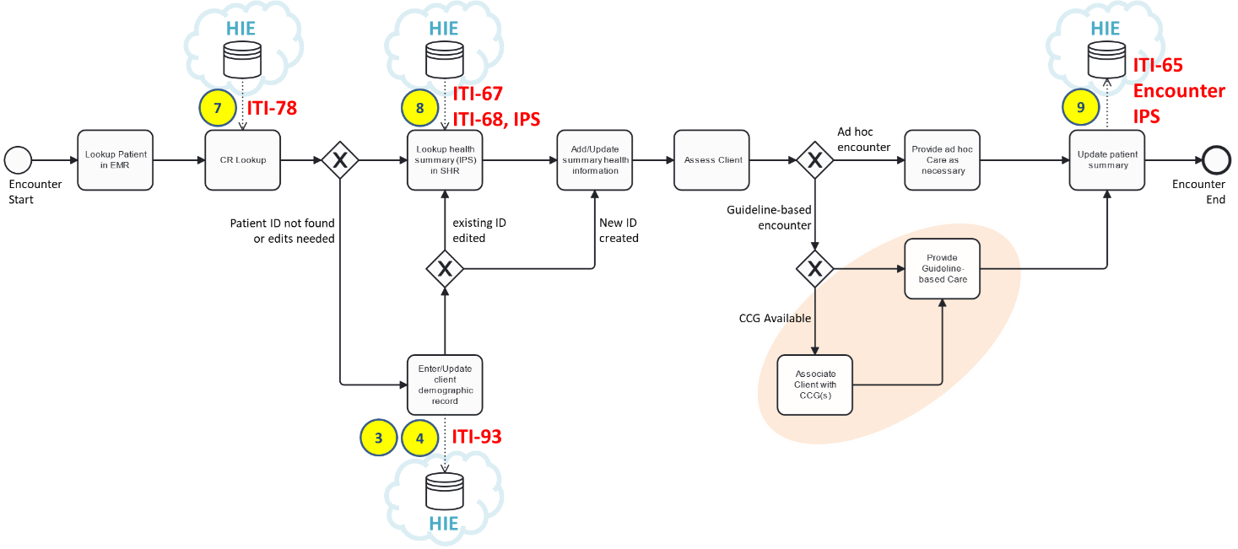

Figure 33 - Generic care encounter pattern

Following the flow of the diagram:

* A person-centric care encounter starts.
* The client’s patient demographic record is looked up in the local electronic medical records (EMR) database.
* The client’s “enterprise” demographic record is looked up in the HIE’s client registry (CR); this is transaction (7) and maps to IHE conformance testable transaction ITI-78.
* If the record is not found in the CR, or if the CR’s record needs to be updated with new information, new content is captured using the CR* POS transactions (3) or (4) and this is saved to the HIE’s CR using IHE transaction ITI-93.
* If the client’s record was found in the CR, the patient summary (IPS) is retrieved from the HIE’s shared health record (SHR) repository. This is transaction (8) in Figure 32 and leverages IHE transactions ITI-67 and ITI-68 and the IPS data specification.
* The client’s IPS is updated with relevant information. In cases where no previous client record existed, the patient summary is created as a brand-new record.
* The client is assessed.
* If it is an ad hoc encounter and guidelines do not apply, care is provided as necessary.
* If one or more care guidelines are applicable, guideline-based care is provided. In cases where relevant CCGs are available, the POS solution may transact with a CCG Engine leveraging transactions 9-17 in a repeating pattern. This latter scenario would occur in the orange-shaded area of Figure 33.
* The patient summary is updated to reflect the activities of the encounter. The encounter details (e.g. client ID, health worker ID, facility ID, timestamp, etc.) plus the client’s updated health summary are persisted to the HIE’s SHR. This is transaction (9) and uses IHE transaction ITI-65 along with the FHIR Encounter and IPS data models.

It is expected that POS solutions will maintain their own (local) copies of health data and that the HIE will be leveraged to share data between and across POS solutions. As a best practice, the originators of new data (e.g. blood pressure reading, lab order, etc.) should be the ones to assign the unique FHIR resource ID and this resource.id should be a standards-based globally unique ID (GUID). As a corollary to this best practice – when a POS solution retrieves content from the HIE, the resource IDs of the retrieved content should be faithfully persisted to the POS’ local database. Adopting this engineering discipline across the care delivery network will allow data management and de-duplication processes to successfully execute at all points of care.

To support high quality, patient-safe, continuity of care – a re-usable data model is leveraged to exchange patient-centric health information within the care delivery network. Following the “off the shelf” risk-mitigation and cost-reduction strategy, the blueprint design leverages the standards-based, conformance-testable data model defined in the International Patient Summary (IPS) specification.[7]

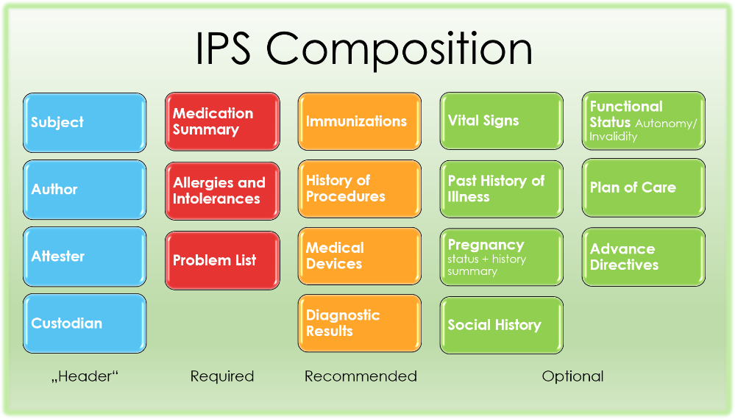

Figure 34 - IPS Data Model

The component data elements of an IPS “document” are listed below along with links to the underlying FHIR data model specifications (those noted with an (R) are mandatory; all others are “required if known”[8]):

* Medication Summary (R) [ [Medication Statement (IPS)](https://hl7.org/fhir/uv/ips/StructureDefinition-MedicationStatement-uv-ips.html) | [Medication Request (IPS)](https://hl7.org/fhir/uv/ips/StructureDefinition-MedicationRequest-uv-ips.html) | [Medication (IPS)](https://hl7.org/fhir/uv/ips/StructureDefinition-Medication-uv-ips.html) ]
* Allergies and Intolerances (R) [ [Allergy Intolerance (IPS)](https://hl7.org/fhir/uv/ips/StructureDefinition-AllergyIntolerance-uv-ips.html) ]
* Problem List (R) [ [Condition (IPS)](https://hl7.org/fhir/uv/ips/StructureDefinition-Condition-uv-ips.html) ]
* Immunizations (S) [ [Immunization (IPS)](https://hl7.org/fhir/uv/ips/StructureDefinition-Immunization-uv-ips.html) ]
* History of Procedures (S) [ [Procedure (IPS)](https://hl7.org/fhir/uv/ips/StructureDefinition-Procedure-uv-ips.html) | [Organization (IPS)](https://hl7.org/fhir/uv/ips/StructureDefinition-Organization-uv-ips.html) | [Device (performer, observer)](https://hl7.org/fhir/uv/ips/StructureDefinition-Device-observer-uv-ips.html) ]
* Medical Devices (S) [ [Device Use Statement (IPS)](https://hl7.org/fhir/uv/ips/StructureDefinition-DeviceUseStatement-uv-ips.html) | [Device (IPS)](https://hl7.org/fhir/uv/ips/StructureDefinition-Device-uv-ips.html) ]
* Diagnostic Results (S) [ [Observation (Results)](https://hl7.org/fhir/uv/ips/StructureDefinition-Observation-results-uv-ips.html) | [DiagnosticReport (IPS)](https://hl7.org/fhir/uv/ips/StructureDefinition-DiagnosticReport-uv-ips.html) | [Organization (IPS)](https://hl7.org/fhir/uv/ips/StructureDefinition-Organization-uv-ips.html) ]
  + Laboratory results [ [Observation (Results: laboratory)](https://hl7.org/fhir/uv/ips/StructureDefinition-Observation-results-laboratory-uv-ips.html) | [Specimen (IPS)](https://hl7.org/fhir/uv/ips/StructureDefinition-Specimen-uv-ips.html) | [Media observation (Results: laboratory, media)](https://hl7.org/fhir/uv/ips/StructureDefinition-Media-observation-uv-ips.html) ]
  + Radiology results [ [Observation (Results: radiology)](https://hl7.org/fhir/uv/ips/StructureDefinition-Observation-results-radiology-uv-ips.html) | [Device (performer, observer)](https://hl7.org/fhir/uv/ips/StructureDefinition-Device-observer-uv-ips.html) | [Imaging Study (IPS)](https://hl7.org/fhir/uv/ips/StructureDefinition-ImagingStudy-uv-ips.html) | [Practitioner (IPS)](https://hl7.org/fhir/uv/ips/StructureDefinition-Practitioner-uv-ips.html) ]
  + Pathology results [ [Observation (Results: pathology)](https://hl7.org/fhir/uv/ips/StructureDefinition-Observation-results-pathology-uv-ips.html) | [Specimen (IPS)](https://hl7.org/fhir/uv/ips/StructureDefinition-Specimen-uv-ips.html) | [Media observation (Results: laboratory, media)](https://hl7.org/fhir/uv/ips/StructureDefinition-Media-observation-uv-ips.html) ]
* Vital Signs [ [Vital Signs](http://hl7.org/fhir/R4/vitalsigns.html) ]
* Past history of illnesses [ [Condition (IPS)](https://hl7.org/fhir/uv/ips/StructureDefinition-Condition-uv-ips.html) ]
* Pregnancy (status and history summary) [ [Observation (Pregnancy: EDD)](https://hl7.org/fhir/uv/ips/StructureDefinition-Observation-pregnancy-edd-uv-ips.html) | [Observation (Pregnancy: outcome)](https://hl7.org/fhir/uv/ips/StructureDefinition-Observation-pregnancy-outcome-uv-ips.html) | [Observation (Pregnancy: status)](https://hl7.org/fhir/uv/ips/StructureDefinition-Observation-pregnancy-status-uv-ips.html) ]
* Social History [ [Observation (SH: alcohol use)](https://hl7.org/fhir/uv/ips/StructureDefinition-Observation-alcoholuse-uv-ips.html) | [Observation (SH: tobacco use)](https://hl7.org/fhir/uv/ips/StructureDefinition-Observation-tobaccouse-uv-ips.html) ]
* Functional Status (Autonomy / Invalidity) [ [Condition (IPS)](https://hl7.org/fhir/uv/ips/StructureDefinition-Condition-uv-ips.html) | [Clinical Impression](http://hl7.org/fhir/R4/clinicalimpression.html) ]
* Plan of care [ [Care Plan](http://hl7.org/fhir/R4/careplan.html) ]
* Advance Directives [ [Consent](http://hl7.org/fhir/R4/consent.html) ]

To ensure semantic interoperability, different data elements in the IPS are *required* to be coded. The normative code systems specified for the IPS are:

* SNOMED International Patient Summary (IPS)[9]
* WHO Anatomical Therapeutic Chemical (ATC) classification system[10]
* LOINC[11]

The IPS has undergone high level evaluation regarding its applicability against key care use cases. It is apparent that the IPS data model, **unmodified**, supports guideline-adherent care workflows related to immunization, antenatal care (ANC), diabetes, HIV, TB, and malaria. It is anticipated that ***all*** the key care workflows needed to address the country’s top-10 burden of disease would be supported without requiring extension or modification of the data model.

## Conformance-testable Building Blocks

**NOTE: The following sections contain normative content intended for a technical audience.** The balance of the technical specification is laid out in eight main sections:

* Terminology Service (TS*/TS)
* Client Registry (CR*/CR)
* Facility Registry (ILR-FR)
* Health Worker Registry (ILR-HWR)
* Shared Health Record repository (SHR)
* Interoperability Layer
* Health Management Information System (HMIS)
* Point of Service Application (POS)

As a tactical matter, the underlying digital health standards are based on **HL7 FHIR R4** and the **IHE Profiles** that operationalize these. The specific IHE Profiles are:

* International Patient Summary (IPS) – which is a data content standard that also references underlying code system specifications:
  + SNOMED International Patient Summary (IPS)[12]
  + WHO Anatomical Therapeutic Chemical (ATC) classification system[13]
  + LOINC[14]
* Mobile Health Document Sharing (MHDS) – which is an umbrella specification that encapsulates underlying IHE Profiles:
  + Patient Master Identity Registry (PMIR)
  + Mobile Care Services Discovery (mCSD)
  + Mobile access to Health Documents (MHD)
  + Sharing Value Sets, Codes and Maps (SVCM)
  + Internet User Authorization (IUA)
  + Audit Trail and Node Authentication (ATNA)
  + Consistent Time (CT)
  + Aggregate Data Exchange (ADX) and Mobile Aggregate Data Exchange (mADX)

This strategy of referencing “off the shelf” specifications leverages the conformance tests that IHE has already defined for each of the Profiles named above.

The full text of the IHE Profiles, and their associated conformance tests (defined using IHE’s open-source testing platform: Gazelle), are not replicated in this document. Rather, links to the applicable artefacts are included in the relevant subsections. Each subsection, however, *will* stipulate configuration and code system requirements. These requirements apply **in addition to** the base IHE specifications. The complete set – the base IHE Profiles ***plus*** these additional terminology specifications – constitutes the **National** **HIE Reference Architecture**.

## Terminology Service (TS)

*[This section describes an implementable, scalable, conformance-testable approach to terminologies for health that well leverages the capabilities of digital health to serve care workflows and health system management indicator reporting. Consideration should be given to the implications of adopting alternate approaches, and the downstream effects that normative codes will have on HIE behaviours. Management of normative codes is a key patient safety issue.*

*This section will need to be edited to reflect alternate approaches, where these are to be adopted.]*

This spec will leverage a FHIR-capable data store as its Terminology Service (TS* in Figure 32). The TS* will be populated with value sets, code systems and concept maps and will operate as per the behaviours defined in the IHE SVCM Profile[15]. The TS* actor will be leveraged by the MOH to manage and map terminologies and to regularly publish relevant code lists. These published code lists will be leveraged to regularly update POS solutions and to update the content exposed by the TS actor in the HIE’s OLTP-optimized FHIR Service. The TS actor will operationalize runtime access to codes in response to POS solutions’ real-time queries.

For the purposes of conformance to this spec, a TS* actor shall be able to:

1. Play the role of a **Terminology Repository** and execute a query value set **ITI-95** transaction, a query code system **ITI-96** transaction, expand value set **ITI-97** transaction, lookup code **ITI-98** transaction, validate code **ITI-99** transaction, query concept map **ITI-100** transaction and translate code **ITI-101** transaction.
2. Persist and retrieve **ICD-10** codes, **ICD-11** codes, **SNOMED IPS** codes, **LOINC** codes, **WHO ATC** codes or other terminological artefacts that an MOH may determine. For example – facility, health worker and health service codes based on the WHO HHFA[16] specification *may* need to be persisted to the TS.
3. Generate code lists and value set extracts, as defined by the MOH, and publish these in a format that may be ingested by conformant POS solutions and by the HIE’s FHIR service. The format(s) of these published extracts will be determined by the MOH (e.g. Excel spreadsheet, PDF, xml or json file, etc.). The method of dissemination of these published artefacts will be determined by the MOH (e.g. GDRIVE, web portal, etc.).

For the purposes of conformance to this spec, a TS actor shall be able to:

1. Play the role of a real-time **Terminology Repository** and execute and return values from a: lookup code **ITI-98** transaction; validate code **ITI-99** transaction; query concept map **ITI-100** transaction; and translate code **ITI-101** transaction.

## Client Registry (CR)

*[This section describes an implementable, scalable, conformance-testable approach to unique IDs for health that well leverages the capabilities of digital health to serve care workflows. Consideration should be given to the implications of adopting alternate approaches, and the downstream effects that patient ID management will have on HIE behaviours. Management of unique IDs for health is a key patient safety issue.*

*This section will need to be edited to reflect alternate approaches, where these are to be adopted.]*

It is expected the HIE infrastructure will include both a CR* actor and a CR actor. The CR* actor will be responsible for client demographic data management and de-duplication (e.g. merging). These are separate from the OLTP-optimized HIE services in order to defend performance requirements. The CR actor will be operationalized as part of the HIE’s OLTP-optimized FHIR Service and will support highly performant responses to patient demographic content queries and correct cross-referencing to relevant SHR data. NOTE: the CR* actor will need to be able to execute real-time synchronization updates to the CR actor as part of its transaction processing.

For the purposes of conformance to this spec, it is mandated that the CR* actor be able to:

1. Play the role of a **Patient Identity Registry** and support patient identity feed transaction **ITI-93** as both an *initiator* and a *responder*, patient identifier cross-reference query transaction **ITI-83** as a responder, patient demographic query transaction **ITI-78** as a responder, and patient update subscription transaction **ITI-94** as a responder. The detailed conformance requirements are defined by IHE’s PMIR Profile[17].
2. Support the demographic content data model defined by the HL7 FHIR International Patient Summary Implementation Guide (**IPS IG**).[18]
3. As part of a single transaction where it is acting as a Patient Identity Registry ***responder***, persist new or updated content to the CR actor via an **ITI-93** transaction (as an ***initiator***).
4. As part of a single transaction where it is acting as a Patient Identity Registry ***responder***, and where the ITI-93 transaction creates a **merge**, update relevant records in the SHR (playing the role of an **MHDS Document Registry** actor) to effect linking of the deprecated patient.id to the surviving patient.id as per the normative behaviours defined IHE MHDS Profile[19].

For the purposes of conformance to this spec, it is mandated that the CR actor be able to:

1. Play the role of a **Patient Identity Registry** and support a patient identity feed transaction **ITI-93** (initiated from CR*, *only*) as *responder*, and patient demographic query transaction **ITI-78** as a responder. The detailed conformance requirements are defined by IHE’s PMIR Profile.
2. Support the demographic content data model defined by the HL7 FHIR International Patient Summary Implementation Guide (**IPS IG**).

For conformance to this specification, the following demographic data are to be persisted, and these data are *required if known*:

* Patient’s full legal name, date of birth, and sex at birth (stored in the gender element)
* Existing ID numbers (e.g. CRVS-assigned ID number, driving license number, locally-assigned clinic ID number(s), etc., where available). In all cases, both the issuing authority ID# and the ID# itself are stored, as a coded pair.
* Patient’s phone number
* A link to the Patient’s mother’s RelatedPerson record will be maintained in the patient.link.other data element with a patient.link.type = seealso. The mother’s RelatedPerson.identifier will be set to her patient.id, if she has a patient record in the CR*, and the RelatedPerson.patient will be set to point to the patient.id. The mother’s full name will be persisted in the mother’s RelatedPerson.name field and the RelatedPerson.relationship field will denote MTH (mother). This information about the mother will be **required if known**, whether she be alive or dead, in order to support demographic lookup of the patient’s demographic record.

As a mandatory CR* (and CR) behaviour, the patient.id shall be a globally unique ID (GUID). Where a “wallet ID” (e.g. a health card) is created for the client, the patient.identifier shall contain the unique health ID that appears on this artefact and the MOH shall be denoted as the issuing authority of the identifier.

In cases where a unique ID is established for an individual but **no health ID card or other artefact is issued** at the time of establishing the unique ID, the patient.id (the GUID) shall be persisted as the patient.identifier with the MOH denoted as the issuing authority. This *temporary* patient.identifier will act as a placeholder until a wallet ID can be created and provided to the client. This temporary placeholder shall be overwritten by the MOH-issued unique ID at the time a card is issued to the individual. This behaviour is intended to support situations where persons need to be set up with a unique ID but where it is not possible to issue them a card at the time their demographic record is created.

The CR shall also maintain and persist any and all locally-assigned IDs in the patient.identifier element (e.g. a locally unique medical records number created by a care facility). In these cases, the assigning authority shall be identified using the MOH-assigned care delivery organization’s org ID. These org IDs shall match valid organization.id records (see the ILR-FR section, below).

## Facility Registry (ILR-FR)

*[This section will need to be edited to reflect alternate approaches, where these are to be adopted.]*



Figure 35 - The Logical Model of an Interlinked Registry (based on IHE’s mCSD Profile)

This specification expects to leverage a FHIR-capable data store[20] as its Interlinked Registry (ILR). It is expected that the ILR will behave as if part of a *single logical* HIE FHIR Service. The ILR will act as the Facility Registry (ILR-FR) and will be populated by one or more underlying facility directories (FD) as defined by the IHE mCSD Profile[21]. As an example, a FD could be a directory of public care facilities or a directory of private sector facilities or a directory of faith-based facilities. As a practical matter, it is often possible to leverage the HMIS as at least one of the FDs to populate the ILR-FR.

For the purposes of conformance to this specification, an ILR-FR shall be able to:

1. Play the role of a **Care Services Selective Supplier** and support queries for Facilities (Location resources), Health Services, Organizations, and PractitionerRole resources via the **ITI-90** transaction, as a responder.
2. Play the role of a **Care Services Update Consumer** and support requests for care services updates via transaction **ITI-91**, as an initiator.
3. As a **Care Services Selective Supplier**, support the **Location Distance Option**.

For the purposes of conformance to this specification, a FD shall be able to:

1. Play the role of a **Care Services Update Supplier** and support **Facility** (and, optionally, **Organization**, **PractitionerRole** and **HealthcareService** resource) refresh queries using the **ITI-91** transaction.

As a mandatory functional capability, the ILR-FR shall be able to be updated to establish relationships between facilities, organizations and health services via the creation or updating of **PractitionerRole** resources. For each unique combination of organization and facility (location), a PractitionerRole resource shall be created that references all the applicable HealthcareService resources for the facility. Where these relationships have been established, they shall be persisted and be updated based on the results of subsequent ITI-91 transactions.

The ILR-FR will be refreshed on a nightly basis from underlying directories using the ITI-91 transaction (which can run as part of a scheduled batch operation). To ensure ongoing data reliability, the ILR will be updated to reflect annual assessments leveraging the WHO’s Harmonized Health Facility Assessment[22] tool.

### Facility type codes

*[This section will need to be edited to reflect alternate approaches, where these are to be adopted.]*

Amalgaland has adopted the questionnaire codes of the WHO’s Harmonized Health Facility Assessment Tool (HHFA) as the code system. The approach is described below.



Figure 36 - WHO's HHFA Questionnaire (Facility Characteristics)

The HHFA question number (column 2 in Figure 36) shall be concatenated with the response ID number (column 4) to create a unique identifier. As an example, this heuristic would be leveraged to generate code 115.01 to denote National Referral Hospital. The question’s scope (column 3) – in this case “Type of Facility” – denotes the *type* of the code or the code’s relevant *concept*.

Following this approach, three relevant code *types* shall be denoted:

* 115 facility type
* 116 facility managing authority
* 117 available service levels

Within these code types, the set of codes may be generated, as per the example above, by concatenating the question ID# with the response number. The concept for each code would be the text of the response. To illustrate, the full list for available service levels shall be:

* HHFA.117.1 outpatient only
* HHFA.117.2 inpatient only
* HHFA.117.3 both outpatient and inpatient

### Health service type codes

*[This section will need to be edited to reflect alternate approaches, where these are to be adopted.]*

Regarding the code list for health services, the WHO’s HHFA questionnaire numbers shall be employed, as illustrated in the previous section. The health services shall be identified by FHIR HealthcareService resources; the HealthcareService.identifier for each unique service shall be by concatenating ‘HHFA.’ plus the HHFA question heading number (e.g. HHFA.14, COMMUNICABLE DISEASE SERVICES; HHFA.15, NONCOMMUNICABLE DISEASES (NCDs), etc.). For each HealthcareService, the description shall be persisted in the HealthcareService.category element. Where a greater degree of precision is needed, the HHFA subcategory question codes shall be employed (e.g. HHFA.14.1, MALARIA, HHFA.14.2, NEGLECTED TROPICAL DISEASES (NTDs), etc.).

## Health Worker Registry (ILR-HWR)

*[This section will need to be edited to reflect alternate approaches, where these are to be adopted.]*

This spec leverages a FHIR-capable data store as its Interlinked Registry (ILR). It is expected that the ILR will behave as if part of a *single logical* HIE FHIR Service. The ILR acts as the Health Worker Registry (ILR-HWR) and will be populated by one or more underlying health worker directories (HWD) as defined by the IHE mCSD Profile[23]. It is expected that an mCSD-capable health worker database (such as, for example, iHRIS[24]) will act as at least one of the HWDs to populate the ILR-HWR. Generally, the membership directories of each clinical association (e.g. physicians, nurses, lab technicians, pharmacists, etc.) shall be leveraged to populate and regularly update the ILR-HWR.

For the purposes of conformance to this spec, an ILR-HWR shall be able to:

1. Play the role of a **Care Services Selective Supplier** and support queries for Practitioners, Facilities (Location resources), Health Services, Organizations, and PractitionerRole resources via the **ITI-90** transaction, as a responder.
2. Play the role of a **Care Services Update Consumer** and support requests for care services updates via transaction **ITI-91**, as an initiator.
3. As a **Care Services Selective Supplier**, support the **Location Distance Option**.

For the purposes of conformance to this spec, an HWD shall be able to:

1. Play the role of a **Care Services Update Supplier** and support **Practitioner** (and, optionally, **Organization**, **PractitionerRole** and **HealthcareService** resource) refresh queries using the **ITI-91** transaction.

As a mandatory functional capability, the ILR-HWR shall be able to be updated to establish relationships between practitioners, facilities, organizations and health services via the creation or updating of **PractitionerRole** resources. For each unique combination of organization, facility and practitioner, a PractitionerRole resource shall be created that references all the applicable HealthcareService resources provided by the practitioner at the facility under the auspices of the organization. Where these relationships have been established, they shall be persisted and be updated based on the results of subsequent ITI-91 transactions.

### Health worker type codes

*[This section will need to be edited to reflect alternate approaches, where these are to be adopted.]*

The list of health worker type codes shall adhere to the health worker types defined by the WHO’s mapping to the ISCO occupation classification standard.[25] Health workers shall be defined using FHIR **practitioner** resources; there will be one practitioner resource for each distinct health worker. The health worker’s type shall be persisted in the practitioner.qualification.code element.

## Shared Health Record Repository (SHR)

*[This section will need to be edited to reflect alternate approaches, where these are to be adopted.]*

This specification leverages a FHIR-capable data store as its longitudinal Shared Health Record repository (SHR). The SHR will persist person-centric health information as an International Patient Summary “document” (IPS) associated with a uniquely identified patient, including metadata related to the document. The SHR will also parse and separately persist the individual resources in a submitted IPS, de-duplicating (as necessary) to ensure the integrity of longitudinal, person-centric data. The SHR will generate an IPS[26] and return it when a query is made for an individual’s health summary. The reference server for such operational capabilities can be found at the ips.health[27] website maintained by the Global Digital Health Partnership (GDHP)[28].

The SHR will play the roles of an **MHD Document Recipient** and an **MHD Document Responder** as defined by the IHE Mobile Health Document Sharing (MHDS) Profile[29].

For the purposes of conformance to this specification, and SHR shall be able to:

1. Play the role of an **MHD Document Recipient** and execute an **ITI-65** transaction when a document bundle is provided, including support for the Uncontained Reference Option as defined in the MHDS Profile.
2. Persist an **Encounter** resource. Where the ITI-65 transaction is conveying an **Encounter** resource, the encounter.identifier shall be a GUID, the encounter.subject shall reference the unique patient ID, the encounter.status shall be either in-progress or finished, the encounter.participant.individual shall reference the unique health worker ID, the encounter.period.start and encounter.period.end shall indicate the start date and end date of the encounter (respectively), and the encounter.location.location shall reference the facility ID.
3. Persist the contents of an **IPS document**. Where the ITI-65 transaction is conveying an **IPS** document, the data elements of the IPS will be persisted to the SHR as individual resources such that any new content is inserted and any edited content is updated and any unchanged content is not duplicated. The IPS’s composition.subject shall reference the unique patient ID, the composition.encounter shall reference the applicable encounter.identifier, the composition.date shall coincide with the applicable encounter.period.end, the composition.author will reference the practitioner identified in the encounter.participant.individual element.
4. Persist a **bundle** containing both an Encounter and an IPS. Where the ITI-65 transaction is conveying both an Encounter resource and an IPS document, the Encounter resource shall be persisted to the SHR before the IPS document.
5. Play the role of an **MHD Document Responder** and execute an **ITI-66** find document manifests transaction, an **ITI-67** find document references transaction or an **ITI-68** retrieve document transaction as defined in the MHDS profile.

## Interoperability Layer (IL)

*[This section will need to be edited to reflect alternate approaches, where these are to be adopted.]*

In this specification, an Interoperability Layer (IL) acts as the shared services bus for the national HIE. The IL enforces the HIE behaviours defined in the IHE MHDS Profile[30] and supports non-functional requirements related to scalability, maintainability and extensibility.

For purposes of conformance to this specification, the IL shall be able to:

1. Play the roles of a **Document Registry** and **HIE Central Infrastructure** as defined by the MHDS profile and enforce all the conditions and behaviours defined for these actors including, where necessary, the enforcement, coordination and orchestration of transactions between different HIE actors.
2. Support the behaviours of the **Authorization** option, **Consent Manager** option, and **UnContained Reference** option, as defined in the MHDS Profile.
3. Support **non-functional requirements** as may be defined by an MOH related to response time, load balancing and scalability, maintainability, performance monitoring, etc.

## Health Management Information System (HMIS)

*[This section will need to be edited to reflect alternate approaches, where these are to be adopted.]*

DHIS2 is designated as the HMIS for Amalgaland. For the purposes of conformance to this specification, it is mandated that the HMIS be able to:

1. Play the role of a **Content Consumer** and receive aggregate indicator reports via the **QRPH-53** transaction based on indicator report definitions that the MOH may publish, from time to time, as conformant ADX schema. The detailed conformance requirements are defined by IHE’s ADX Profile[31] and may be tested using the IHE Gazelle[32] platform.
2. Play the role of a **Care Services Update Supplier** and respond to queries for up-to-date **Facility** and **Organization** content using the **ITI-91** transaction. The detailed conformance requirements are defined by IHE’s mCSD Profile[33].



Figure 37 - Anticipated Evolution of HMIS Traffic, over time

There is expected to be an evolution, over time, in how content is fed to the HMIS. As there is broader adoption of person-centric digital health solutions, more and more of the content in the HMIS will come from regular extracts on SHR data and less and less will be uploaded (by hand) to the HMIS’ web forms. This evolution has advantages, not least of which will be the liberation of health worker time and effort that is, today, spent on tally sheet data entry.

There are also opportunities to leverage increasing person-centric traffic on the HIE to generate large, de-identified, person-centric data sets in the HMIS. Such data sets support innovative opportunities for advanced analytics, including machine learning and other AI techniques. Such an option is suggested by the “T-junction” shown in Figure 32.

### Implications for Cross-domain Integration

The health transaction workflows illustrated by Figure 32 do not include other companion domains, such as supply chain or health financing. It is anticipated that the HMIS and its analytic capabilities will be leveraged to loosely couple the HIE to enterprise systems that support these cross-domain workflows. An example, follows, related to how HIE transactions can support the automatic development of supply chain transactions that may be uploaded to logistics management information systems (LMIS) at regular intervals (e.g. in a nightly batch, or monthly report, etc.). A medication stock management workflow is used to illustrate.

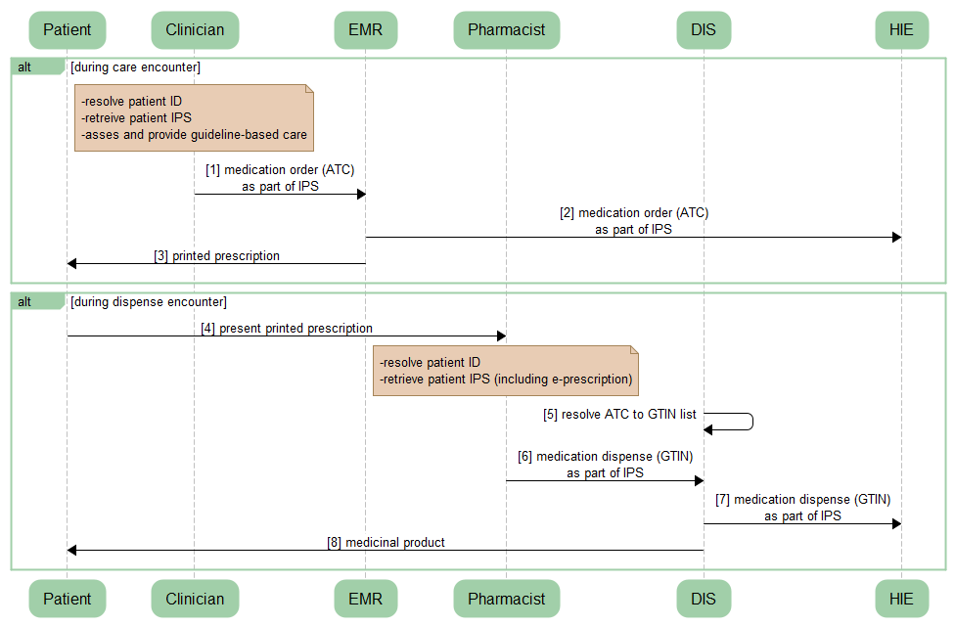

Figure 38 - Medication Order / Dispense Transactions

A generic mediation order / dispense workflow is illustrated in Figure 38. Following the transaction flow:

* During a care encounter, a clinician may order medications for a patient. The medication order is recorded in the EMR and communicated to the HIE as an update to the patient’s IPS-based health summary document (transactions [1] and [2]). A printed prescription is provided to the patient (transaction [3]). Importantly, the electronic medication order is coded using WHO’s Anatomical Therapeutic Chemical (ATC) classification code list. At the time of the order, the **drug** is indicated – but not its brand name or its packaging configuration.
* When a patient presents his or her prescription to a pharmacist (transaction [4]), the pharmacist uses a Drug Information System (DIS) to resolve the patient’s unique ID and retrieve the patient’s IPS-based health summary, including their electronic medication order, from the HIE.
* The DIS uses a mapped database to cross reference WHO ATC codes to GS1 Global Trade Item Number (GTIN) codes (transaction [5]). GTINs are globally assigned and managed codes used by *all* drug manufacturers; they are the identifiers barcoded on the packaging of medications.
* From the list of candidate **medicinal** **products**, the pharmacist chooses which to dispense to the patient based on the MOH’s formulary, on stock availability, and on the insurance coverage (and perhaps personal choice) of the patient (transactions [6], [7], and [8]).

The importance of the ATC-to-GTIN mapping database cannot be overstated. Prescription transactions shall be coded using **drug** codes (ATC); dispense transactions are coded using **product** (GTIN) codes. Computable care guidelines, and important patient safety routines such as drug-to-drug interaction algorithms, are expressed using ATC codes. For its part, the dispense transactions’ GTIN contains manufacturer and lot number information that is important for post-market surveillance (regarding reactions, for example) and is essential in supporting medication recall workflows, if necessary.

The GTIN-based transactions also provide essential information needed by the LMIS to support usage analytics that underpin stock replenishment and management decision-making. A similar mapping of clinical activities to supply chain consumption may be done for HIE transactions related to immunizations, lab tests, surgical procedures, etc. This same cross-domain pattern may be employed, beyond supply chain transactions, to support integrations to health insurance transaction processing and other key supporting workflows.

Amalgaland’s ATC-to-GTIN maps shall be maintained in the HIE’s TS.

## Point of Service application (POS)

*[This section will need to be edited to reflect alternate approaches, where these are to be adopted.]*

Point of service (POS) applications shall adhere to a pattern of processing that enables them to be “well behaved” digital health participants in the HIE. This pattern was illustrated in Figure 33 (replicated below, for ease of reference).

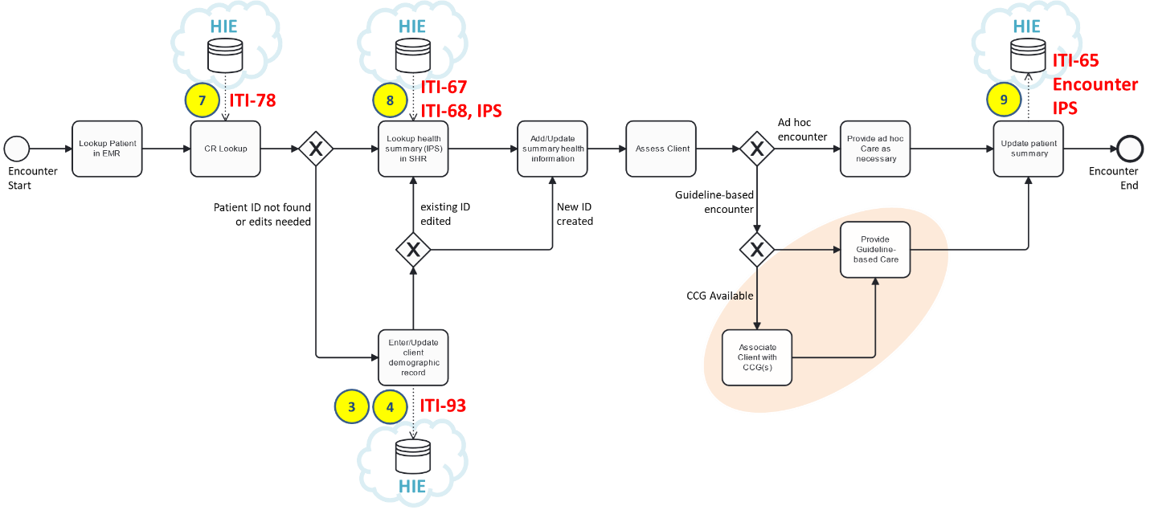

As predecessor steps **prior** to the beginning of the care encounter workflow (not shown in the figure), the application shall enable the health worker to login and to establish the context of care delivery. It is mandatory that digital health applications are secure and that they protect access to personal health information (PHI) by requiring authentication of health workers via, at a minimum, unique user login credentials. It is also mandatory that an application can cache the health worker ID and the location ID once the login is accomplished; these data are needed to support transaction processing with the HIE for every patient encounter.

Referencing the figure, the care encounter workflow steps may be described as follows:

1. The patient is looked up in the local digital health application (e.g. the EMR).
2. The same patient lookup is executed against the CR as an **ITI-78** transaction.
3. If the patient demographic content from the CR needs to be updated, or if the patient is not found and needs to be entered into the CR (and locally), the workflow progresses to the Enter/Update Patient data step. At this step, the updated or new patient data is persisted to the CR via an **ITI-93** transaction. NOTE: the patient.id GUID will be assigned by the CR* POS solution actor and will be faithfully persisted by the CR. If a health card or other “wallet ID” cannot be issued at the time a new demographic record is being created, this GUID is also persisted as the MOH-assigned identifier (patient.identifier). If the POS solution is **not** playing the role of the CR* POS actor, then following this step in the encounter (which will accomplished using the CR* POS), the POS solution will **return to step 2** of this process.
4. If the patient update is completed, or if it was not needed in the first place, the patient’s health summary “id” is queried from the HIE using an **ITI-67** transaction and retrieved from the HIE via an **ITI-68** transaction, which returns an **IPS** document as the query response.
5. The IPS content is reconciled with the local data and both are updated as appropriate. If no IPS was returned by the HIE, then the appropriate background and health history information is captured, in its entirety, during this workflow step.
6. The patient is assessed to determine the presenting issues and to ascertain whether the encounter’s care pathway will be to provide ad hoc[34] care or whether the patient’s encounter should follow a guideline-based care plan.
7. If the encounter should follow a guideline-based care plan, and if a computable care guideline (CCG) is supported, then the appropriate CCG is leveraged. NOTE: this specification is silent on how the CCGs are made available to the POS solutions. There *may* be circumstances where the CCG is retrieved from the HIE via an ITI-68 transaction, which returns the CCG bundle – but it is not expected that these would be runtime transactions during the encounter.
8. The patient receives either guideline-based care or ad hoc care, as appropriate. The care encounter context is logged, and the care activities are faithfully updated to the POS’ database. An **encounter** resource is created which is uniquely identified by a GUID, and which cross-references the provider ID, facility ID, client ID, and care encounter timestamp. This encounter resource plus a new **IPS** document (updated to contain the results of the present encounter) are together submitted to the HIE, in a single bundle, using the **ITI-65** transaction.

For purposes of conformance to this spec, a POS shall be able to:

1. Authenticate a health worker and establish both the health worker’s unique ID and the unique ID of the care facility. For authentication, the application *may* have to play the role of an **IUA Authorization Client** and execute **ITI-71** (or implement some functionally equivalent authentication mechanism, such as public key infrastructure (PKI)). To fulfill these mandatory requirements, a POS solution *may* be required to play the role of a **Care Services Selective Consumer** and execute an **ITI-90** transaction as defined by the mCSD profile. It is mandatory that the application will also need to be able to play the role of a **CT Time Client** and execute **ITI-1** and play the role of an **ATNA Secure Node/App** and be able to execute transactions **ITI-19** and **ITI-20** as defined in the IHE ITI Technical Framework.
2. Play the role **Patient Demographics Consumer** and execute transaction **ITI-78** and as defined in the PMIR profile.
3. If supporting the **CR* POS** role[35], play the role of a **Patient Identity Source** and execute transaction **ITI-93** as defined in the PMIR profile.
4. Play the role of an **MHD Document Consumer** and execute transactions **ITI-67** and **ITI-68** as defined in the MHD profile. A received **PCC-IPS** health summary document must be ingested, parsed, and persisted to the application’s local data store.
5. Play the role of an **MHD Document Source** and execute transaction **ITI-65** as defined in the MHD profile. The **IPS** health data content profile must be generated from the content in the local data store as normatively defined in the IPS profile. NOTE: it is essential that resource.id values are properly managed by the POS solution. Resource id’s contained in IPS documents returned by HIE queries must be faithfully persisted to the local data store and faithfully returned in any updated IPS document. For *new* IPS content reflective of the activities of the encounter, the POS solution must generate GUIDs for all relevant resource.id values.
6. On a periodic basis, the POS solution *may* be required to play the role of a **Content Creator** and submit indicator reports to the HMIS via the **QRPH-53** transaction as defined in the ADX profile. Such report schema will be defined by the MOH and POS solutions will be conformance-tested to confirm their ability to correctly generate reports adherent to these schemata.

For a **dedicated** CR* POS solution that is **only** used for onboarding new client demographic records, only requirements 1, 2 and 3 (listed above) must be met.

Amalgaland’s MOH will provide all care sites with a dedicated CR* application. This application shall be employed for all demographic record creation and editing functions.

# Digital Health Landscape and Quick-win Opportunities

**Key points:**

Point One…

Point Two…

Point Three…

**Key recommendations:**

Recommendation One

Recommendation Two

*[In this section, a listing should be made that reports the current digital health landscape, with particular focus on solutions that have been widely deploy and which may be able to be incorporated into the national HIE either at the cloud (shared infrastructure) side or the POS side.*

*Based on the functional footprint of the solution, it should be mapped to the actor or actors listed in the previous section. It is common for legacy, purpose-built solutions to play the role of multiple actors. A widely implemented EMR solution, for example, will contain client demographic data (CR) as well as person-centric health information (SHR). The solution may be anticipated to play one or both of these roles as part of the national digital health infrastructure initiative – or it may be simply that the extensive data stores in a solution will be leveraged to “seed” national registries, which will be separately deployed in the cloud.*



*As a practical matter – if there are legacy solutions that are to be incorporated as part of the national infrastructure, a* ***façade*** *approach has many advantages. An example of such an approach is illustrated by the graphic above. Where there is an existing health worker database solution and an existing facility registry solution, these may be incorporated into the HIE by adding ITI-91-conformant façades to each solution. Technically, each façade would map between the data models of the legacy solution and the data models of the conformant FHIR-based IHE Profile (in this example, the mCSD Profile). On a regular batch (run daily, perhaps), the map would be used to synchronize content from the legacy solution to the HIE’s FHIR Server.*

*Such an approach minimizes the software changes needed to operationalize a conformant HIE FHIR Service. At the same time, the MOH can continue to leverage existing data integrations and existing governance processes associated with the legacy solution.*

*This section need not be exhaustive; there does not need to be an inventory of every digital health solution used in the country. Rather – it should highlight large scale solutions that will either become part of the new infrastructure or will need to be modified (possibly leveraging a façade pattern) so that they can connect. Where there are key opportunities to accelerate the time to value, these should be identified, and the level of effort associated with leveraging legacy solutions should be estimated.]*

This section lists key digital health solutions, their use cases, where they are deployed, who is supporting them, and germane technical attributes (where known). These are mapped to the architecture described in Figure 32 and implications and quick-win options are discussed.

## High-level overview of broadly deployed digital health solutions

<Insert a list of broadly deploy solutions and discuss their present deployment status and germane technical information (such as data or interoperability standards supported by the solution).>

As noted in the section, **Error! Reference source not found.**, DHIS2 will be incorporated into the national HIE. Other broadly implemented solutions were also evaluated by the TWG. These are listed below.



Figure 39 - Legacy solution: CHIES



Figure 40 - Legacy solution: E-Heza



Figure 41 - Legacy solution: CHAP



Figure 42 - Legacy solution: ANC CCG Module



Figure 43 - Legacy solution: Umurinzi

It was a consensus opinion of the TWG that three POS solutions would be connected to the HIE as priority “accelerators”. The three are: E-Heza, the ANC CCG Module, and Umurinzi. As noted previously, consideration will be given to the CHIES solution as an option for the HIE’s Interoperability Layer (IL), subject to performance and scalability challenges being addressed.

## Mapping existing solutions to HIE actors

<Leveraging the nomenclature of Figure 32, define how applications (or subfunctions within applications) will map to the HIE infrastructure. Provide estimated level of effort to achieve integrations as well as top-level descriptions of strategies (e.g. façade approach, etc.) and their implications.>



Figure 44 – Façade pattern

It is anticipated that a software façade pattern will be employed to connect legacy solutions to the HIE that do not, today, have a standards-compatible application programming interface (API). This approach is illustrated in Figure 44.

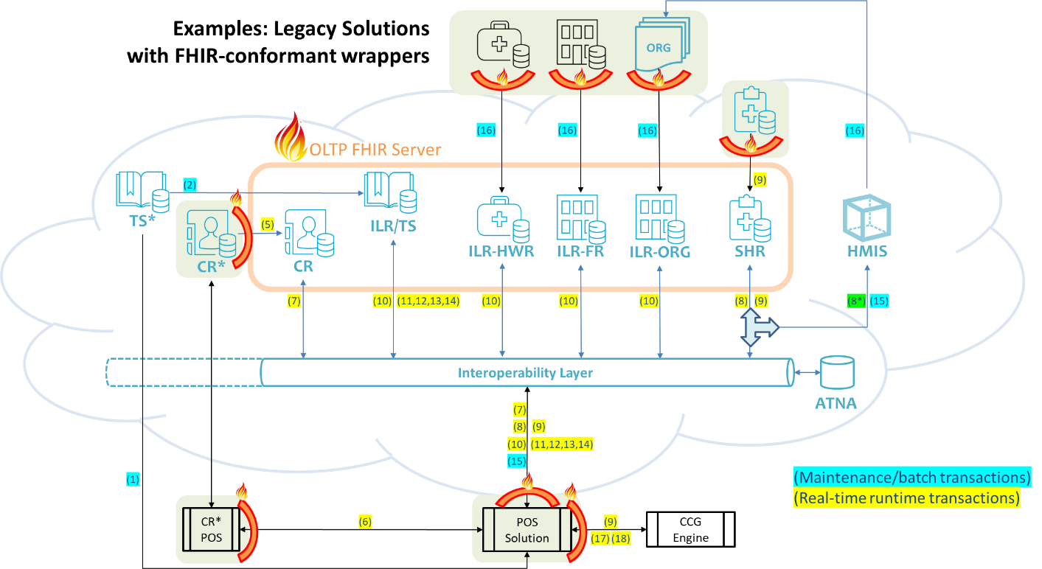

Figure 45 - Examples of façades connecting legacy solutions to the HIE

For the three candidate POS solutions that were identified by the TWG as “accelerators”, it is anticipated that façade APIs will be needed to connect them to:

* the HIE
* a CCG engine; and
* a dedicated client registry onboarding solution (CR*).

All the three POS solutions are open source. Although the façade APIs will ease their connections to the HIE infrastructure, it is anticipated that modifications will be needed for them to adhere to the 1-2-3-4 pattern and act as good HIE citizens.

# Governing the National HIE

**Key points:**

Point One…

Point Two…

Point Three…

**Key recommendations:**

Recommendation One

Recommendation Two

*[This section describes important policy and governance elements necessary to support the HIE and the legal basis of its operations. The country context must be reflected in this section. Existing laws and government policies relevant to health data sharing should be cited. National privacy and consent norms may differ (possibly substantially) from those outlined below as example text.*

*Elements of the following example text and/or the graphics may be leveraged as archetypal language. It should be noted that these graphics and text have been leveraged in multiple countries to inform updates to existing legislative frameworks and to inform the establishment of new programme management offices (PMO) to support national HIE initiatives.]*

This section describes policy options which could be leveraged ensure the necessary legal basis is in place for nation-wide sharing of person-centric, protected health data. A digital health governance framework is proposed which would coordinate efforts across all national projects and programmes.

## A conceptual policy framework for national scale health data sharing

This section describes a policy structure that supports national scale health data exchange across both private and public sector care providers.

Two key digital health related policy recommendations are anticipated to be especially impactful and foundational in support of the national HIE:

* Health Data Governance Policy
* Health Data Sharing Policy

### Health Data Governance

To support the large-scale implementation of digital health care delivery solutions, it is essential that the applicable rules of person-centric health data management and governance are defined and enforced for all parties, both in the public sector and the private sector. To provide a legal basis for a national HIE, regulations must define the parties over whom governance will be exercised. Thethree relevant parties are: health data *owners*; health data *custodians*; and health information *network providers*.

It is an international best practice that data about the care subject is *owned by the care subject*. Care provider organizations are *health data custodians*. The MOH, or related agencies or departments, become *health data custodians* when they maintain person-centric data holdings in shared health record (SHR) repositories or other related registries that form components of the national HIE. Parties that process health data, but **do not retain** it, are not custodians but are considered *network providers*.

Different regulations apply to health data *owners*, health data *custodians*, and health information *network providers*. Typically, as the owner of data about himself or herself, a subject of care should have a right to access their own data and may share their personal health data with whomever they choose. This right applies to digital data in the same way as it would apply to paper copies of personal health data. Health data custodians are generally required to safeguard data holdings, ensure they are available when they need to be, and ensure they are only used by authorized persons for authorized purposes. All healthcare providers are health data custodians. Network providers are typically required to ensure the integrity of the content they convey and to ensure that their operational processes do not inadvertently create data holdings that would cause them to become a custodian. These actors are depicted in Figure 46.



Figure 46 – Conceptual Health Data Governance Actors

*[There are useful examples of Health Data Governance legislation that may be employed as models to consider in drafting its domestic legislation. As an example, from Canada, the Province of Ontario’s Personal Health Information Protection Act (PHIPA, 2004)[36] outlines a model regulatory framework for health data owners, custodians, and network providers.]*

### Health Data Sharing

To operationalize the national HIE, Health Data Sharing legislation may be needed to provide a legal basis for its operation. There are two key aspects to be addressed by such a policy framework:

1. Patient consent management; and
2. Patient rights related to safety and quality of care.

As a best practice, patient consent regarding health data sharing should be based on an **implied consent** or *opt-out* model. In plain terms, this means a patient’s data will be shared within the care delivery network, for the purpose of delivering care to that patient, unless the patient explicitly decides they wish to *withdraw* their consent for such sharing. This option is preferred over explicit opt-in consent because of its fundamentally easier implementability and scalability. That said, it is important that citizens *must* have the right to withdraw their consent to share their data. This right is foundational to the notion of health data ownership referred to in the previous section.

As a useful example of what is the scale of consent withdrawals that can be expected, of the 5.1 million patients with records in the National Electronic Health Record (NEHR) system in Singapore, approximately 0.01% have opted out of data sharing.[37] Even though these numbers are low – without the option to withdraw consent there is no actual right of privacy on the part of the citizenry. It is a must-have.

Typically, a patient can withdraw their consent to data *sharing*, but cannot withdraw their consent to have their data *collected*. This distinction is important. Patient-level health data *collection* is necessary to support key business processes. Care provider organizations need these data for managing provider payments processes, meeting medico-legal requirements, and satisfying regulations related to mandatory notifiable public health reporting. Usefully, such a collect-but-not-share policy approach means that content that was collected during the period when consent had been *withdrawn* can again be shared if the patient reconsiders their decision and later reinstates their consent for data sharing. The collect-always and share-by-default approach is illustrated in Figure 47.



Figure 47 – Conceptual Data Sharing Consent Model

As a matter of implementability, it is useful to adopt as a default policy that *all* health data will be shared with *all* care providers unless consent to do so has been revoked. Although it is *theoretically* possible to articulate fine-grained data sharing rules that can describe consents to share *some* content with *some* care providers and other content with other providers – the practicalities of such approaches are daunting.

For these reasons – as a starting point – a simple consent policy is recommended that affords the patient the right to choose to be either *all-in* or *all-out*. This *all-in* default behaviour is illustrated in Figure 47. The patient’s consent directive decision gate (black diamond) will share data across the care delivery network (data flows shown in green) *unless* the patient’s consent rule is explicitly set to **NO**.

There have been, in some jurisdictions, challenges in having private sector actors share patient data (which they may regard as *customer* data). To combat issues related to health data blocking or hoarding, health data sharing policy should be framed as a patient *rights* issue. The premise for such an approach is that each patient is entitled to safe, high-quality healthcare. The delivery of safe, high-quality care relies on good care continuity and this, in turn, relies on health data sharing across the care delivery network (including *both* public and private sector providers).

This premise is also illustrated in Figure 47 where it may be noted that data flows on a mandatory basis from Direct Care Providers to patients (as owners) and to the MOH (who, alongside the Direct Care Provider, is also a custodian). These MOH data holdings are operationalized by the secure data sharing infrastructure of the HIE. In situations where private sector players have been reticent to share health data about their patients, framing the data sharing as a *patient rights issue* establishes a legal basis for prohibiting *data blocking* or *hoarding[38]* by care providers.

*[There are examples of health data sharing legislation that may be leveraged to inform policy development. The College of Physicians and Surgeons of Ontario (Canada) has a Medical Records Management[39] policy that includes stipulations about clinicians’ local electronic data storage. On a jurisdictional basis, a data exchange policy example may be taken from the Ontario Health Digital Health Playbook.[40] As an example of anti-data-hoarding legislation, the US health data sharing policy CMS-9115-F[41], the Interoperability and Patient Access final rule, provides a good example. There is also a good example of policy analysis from the European Patients Forum[42] regarding how recent EU legislation regarding health data sharing may be viewed from a patients’ benefits viewpoint.]*

### TWG Recommendations

Based on TWG feedback, the following are recommended as policy action items that should run in parallel to the HIE’s technical deployment efforts:

* There are presently policy gaps related to an explicit definition of data **owner** and a clear delineation of data **network providers** as separate from data custodians. It is recommended these be clarified.
* Although health data is mentioned as an example of private data, there is no clear definition of **direct patient care** as an allowed **purpose of use** for health data managed by a custodian. It is recommended this explicitly be defined as an allowed purpose of use.
* With the anticipation of **AI training data sets** as being important to progressing this technology in Amalgaland, a clear policy on the use of person-centric health data for this purpose of use should be defined, with appropriate **guardrails** to ensure the public good is served.
* Although it is not explicitly defined by the existing legislation, the present default policy regarding data sharing appears to be “opt-in/no-BTG/individual-carer/any-purpose”. In the interests of **implementability**, the TWG recommends MOH to consider adopting an explicit healthcare policy related to data sharing that would favour a **default** where health data is shared unless consent is withdrawn (**opt-out**), with no “break the glass” (**no-BTG**) capability for care providers to circumvent a person’s consent directive, and that *all* of a person’s health data will be shared with *all* members of the care delivery network (**whole-network**) for the purposes of care delivery (**care-purpose**). A person would have the right to withdraw their consent to data sharing (but not to data *collection*).
* MOH clearly articulate its health data sharing policy scope to include private sector care providers.
* MOH begin drafting policies that would support individual citizens’ ability to authenticate themselves to an online portal for the purposes of being able to access their own health data.

## Exerting MOH governance over disparate digital health projects

To operationalize the national HIE, it will be important to coordinate and govern the activities of multiple stakeholders and their projects.



Figure 48 – Conceptual DH Governance Structure

Figure 48 illustrates a conceptual digital health governance structure informed by country examples that were generally adherent to the Paris Declaration.[43] Such a governance structure may be leveraged to coordinate digital health activities. Its operation may be described, at a high level, as follows:

* The Government may benefit from grants and/or loans from Development Partners. Some funds may directly be targeted to health-related initiatives or to digital health, specifically; others may be more general.
* The Government empowers and funds the Ministry of Health (MOH) to execute activities within its national mandate. Successful execution of this mandate relies on digital health, which will receive project funding for new initiatives and sustaining funding for ongoing operations.
* MOH and its relevant departments and agencies will engage with Development Partners to coordinate activities and to ensure projects and programmes are aligned to MOH’s strategies, priorities, timelines, and the norms and standards documented in its digital health blueprint.
* MOH will empower and fund a Digital Health Department (or Agency) to be the body that exercises the specific mandate related to executing the national digital health strategy. This department will operate a Programme Management Office (PMO) that exerts governance over **all** digital health projects in the country. All Project Managers (PMs) will coordinate their efforts under the auspices of the PMO regardless of whether they are overseeing MOH-funded or Development Partner-funded projects.
* As an instrument of this governance, the Digital Health Department will conduct the conformance testing of implemented solutions to ensure they are adherent to the national norms and standards for digital health. All digital health solutions, whether implemented by public or private sector entities, will be subject to successful conformance testing before they can participate in the national HIE.

The Digital Health Department will also have a role in addressing digital health skills gap. Capacity-building, generally, will focus on requirements related to ongoing HIE operation. To address short-term requirements, external capacity will be leveraged to support one-time tasks related to implementation. All external contractors will operate under the governance of the PMO. Specific train-the-trainer capacity-building will be used to close gaps in frontline workers’ abilities to leverage digital health at the point of service, and to close gaps related to IT technical support within the care delivery network.

Specifically related to pandemic and epidemic preparedness and response, the Digital Health Department may explore opportunities to collaborate with Mobile Network Operators (MNOs) through the GSMA’s M4D initiative.[44] Such collaboration may help address challenges related to big data analytic capacity shortfalls that can be important in addressing public health emergencies.

In summary, it is expected that the activities of the Digital Health Department will include:

1. Operating the Programme Management Office that exerts governance over all digital health projects and programmes (including projects executed by the MOH and those of development partners).
2. Operating the national digital health conformance-testing platform. This platform should include both a 24x7x365 sandbox that may be employed by innovators to experiment against a reference implementation plus an assessment test rig that could be employed to certify digital health solutions against the norms, standards and mandatory behaviours delineated in the Digital Health Blueprint.
3. Providing a Center of Excellence in digital health that can provide thought leadership to inform decision makers and policy makers at MOH and in the Government as well as develop and disseminate educational materials to be leveraged by participants throughout the digital ecosystem (e.g. academia, private sector start-ups, and care delivery participants at all levels of the network).

### TWG Recommendations

Based on TWG feedback, the following are recommended as PMO governance structures and activities in support of the national HIE deployment efforts:

* Funding was identified by the TWG as a key project risk. As one of the mitigation efforts, it is recommended that a clearly defined and **formalized “pooling” strategy and policy** be adopted so that disparate digital health project funds can be *collectively* leveraged in support of the MOH’s HIE initiative.
* Coordination will be a key to success. To mitigate the time and cost inefficiency of uncoordinated digital health implementation efforts, it is recommended the MOH enact policies that enable the MOH’s PMO to exert **explicit** **governance** over the multiple disparate projects that will be concurrently executed in support of the national HIE effort.
* MOH should definitely identify the **Digital Health Steering Committee** and the **Digital Health Technical Working Group** as arms of a **Digital Health PMO** that will be set up as directly reporting to QMD as part of the Digital Health Division. This PMO will require a clear TOR.

# Conclusion & Next Steps

*[This section describes the process for leveraging the present document to inform MOH’s National Digital Health Blueprint. Sample text is included below. This sample text should be edited to appropriately reflect the country’s context and its plan for dissemination of the blueprint and its accompanying specifications.]*

The target audience of the present document is the MOH. The role of *this* document is to inform the publication, ***by the MOH***, of a set of national Digital Health Blueprint artefacts. These will be reference artefacts; they will be published in Amalgalandish. The overall “Blueprint” shall be released in two complementary parts, each part focused on a defined audience.

## Developing the Blueprint Artefacts

### Amalgaland’s National Digital Health Blueprint

This Blueprint document shall target non-technical health system stakeholders who have an interest in the digital health agenda and will participate in the national implementation, whether actively or as supporters. This document will “make the case” for the national plan.

To establish **context**, it will summarize content from the *Burden of Disease*, *Digital Health Readiness*, and *National Health and Digital Health Strategies* sections of the present document. To indicate the MOH’s chosen technology-related **direction**, summary information and graphics from the *Overview and background* and *Conformance-testable Building Blocks* subsections of the *Components of a “buildable” Health Information Exchange* section will be leveraged. Technical details of the implementable specifications will not be included; rather the Blueprint document will refer to the companion document: Amalgaland’s National Norms & Standards for Digital Health.

The **concluding** section of this Blueprint will describe the Ministry’s planned governance structure and note relevant legislative changes that will be enacted to support the national HIE project. High level references will be made to the Investment Rationale and the budget, timeframe, and health impact (ROI) targets that it establishes.

### Amalgaland’s National Norms and Standards for Digital Health

This technical specification will be targeted to health informatics professionals who will be involved in the design and deployment of conformant digital health infrastructure and point of service solutions. It will not replicate the contextual information included in the Blueprint, but rather will refer to it.

High level conclusions from the present document’s context-setting chapter will be summarized in a short **introduction**. The *Components of a “buildable” Health Information Exchange* section will be leveraged, in its entirety, as the normative description of the national norms and standards. Decisions to incorporate existing legacy solutions (as described in the *Digital Health Landscape and Quick-win Opportunities* section), will be described, and an illustrative architecture diagrams will be included.

The **concluding** section of this Norms and Standards specification will describe the MOH’s planned approach for conformance-testing as well as providing information regarding industry support (e.g. prototyping environments) that will be provided to assist technical teams in meeting the national requirements. Citations will be provided that reference relevant legislation regarding the normative requirements for digital health solutions.

## Publication and Dissemination

The national Blueprint artefacts will be officially published and noted in the government’s Gazette. The National Norms and Standards for Digital Health will be officially adopted by enacting a Policy of the Ministry of Health that references this national specification and establishes an enforceable requirement that digital health solutions in Amalgaland’s care ecosystem shall operationalize these specifications and shall connect to the national HIE within a four year timeframe.

The governance structure of the MOH will adopt ownership of both the Blueprint and the Norms and Standards. Both documents will be refreshed on the timeframe established by the Policy. Maintenance of the Norms and Standards will be taken on as an ongoing responsibility of the Digital Health Department.

# Appendix 1: Example Use Case – Diabetes

This section outlines an example workflow for guideline-adherent diabetes care. It includes the mandatory behaviours necessary for good HIE “citizenship”, such as establishing a unique client ID, obtaining a patient summary from a shared repository, providing guideline-based care during an encounter, and updating the shared health record repository with the encounter’s details. It will describe the NCD workflows in terms of the blueprint’s transactions and illustrate the conformance-tests that could be applied to a digital health solution to demonstrate that it is adherent to the blueprint. This set of scenarios could be used for demonstration purposes (e.g. at a conference or an AeHIN Convergence meeting) or for testing purposes at an official MOH “Projectathon” event.

## Archetypal Transaction Patterns

This example use case is expressed using a simplified set of archetypal transaction patterns operating within a digital health architecture that includes the key actors identified in Figure 32. For these archetypal patterns, the relevant participants are:

* patient – the subject of the care encounter
* HW – the health worker that is the provider of care during the encounter
* app – the digital health solution used by the health worker
* IL – the interoperability layer actor that supports security, authentication, and transaction orchestration between the app and the other actors in the digital health shared infrastructure
* CR – the client registry actor that supports resolution of the patient’s unique ID
* ILR – the interlinked registry actor that supports resolution of unique facility, organization, health worker, and health service IDs and codes
* SHR – the shared health record repository that contains health summary documents based on the International Patient Summary (IPS) specification as well as encounter records and, if applicable, computable care guideline records (CCGs)

At a top level, the transaction pattern may be described as follows:

A HW logs into their app and their credentials are established, including their access rights to the HIE. An HIE transaction (TX-A) establishes their care context. An access token is obtained, the HW ID, facility ID and organization ID are resolved, and the app is ready to begin recording care encounters.

FOR EACH CARE ENCOUNTER…

The patient’s unique ID is established (TX-B)

The patient’s health summary is retrieved from the national HIE (TX-C)

Guideline-based care is provided, leveraging one or more CCGs (TX-D)

A record of the Encounter, including the updated health summary, is posted to the national HIE (TX-E)

At the end of the work session, the HW logs out of their app

This top-level transaction pattern is illustrated in Figure 49. The details of each transaction are described in the following subsections.

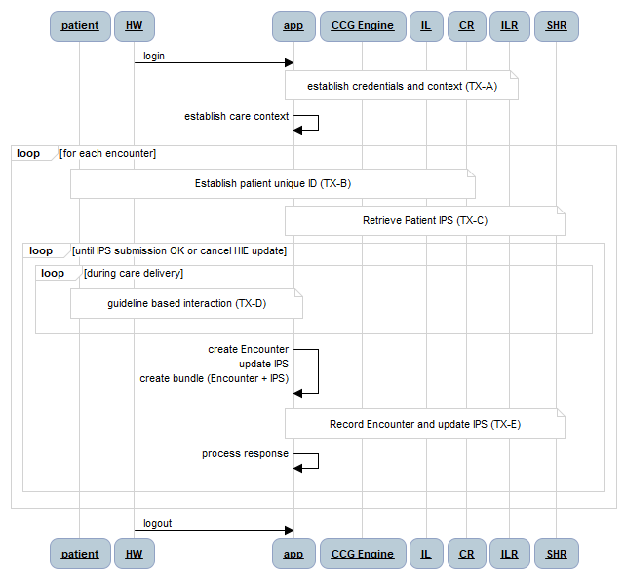

Figure 49 - Top-level Transaction Diagram

NOTE: it is assumed that ***all*** HIE transactions traverse the interoperability layer (IL) and that this enterprise service bus authenticates and authorizes HIE access. For brevity, it is not illustrated on the sequence diagrams that follow, but **all** HIE transaction will need to be coupled with an OAuth token (a companion ITI-72 transaction). As shown in the diagrams, **all** HIE transactions are audited using the IHE audit trail and node authentication, ATNA, transaction). Where necessary to meet the criteria outlined in the IHE MHDS specification, the IL will orchestrate transactions and enforce data consistency rules. These internal IL processes are not shown in the diagrams.

### TX-A: Establish HW credentials and care context

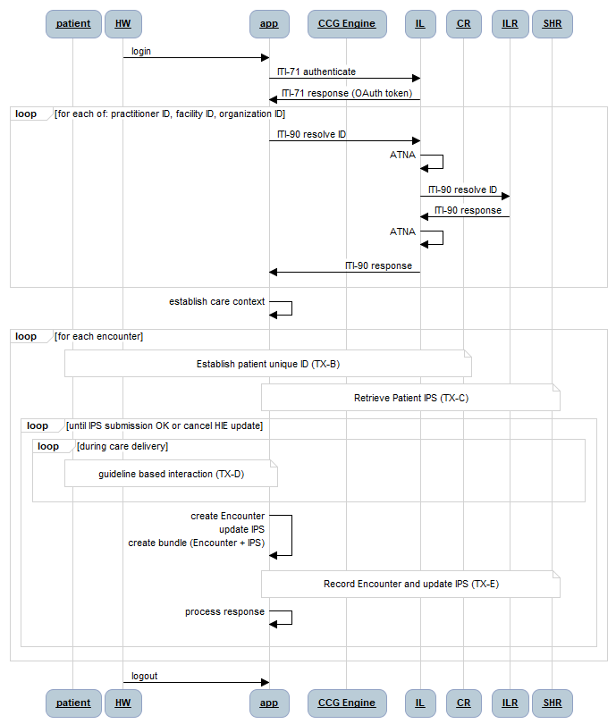

Figure 50 – TX-A: Establish Authorization and Care Context

The authentication, authorization, and care context transaction set (TX-A) is described in the sequence diagram in Figure 50. The health worker logs into his or her digital health solution (app) and the login credentials are leveraged to establish authorized access to the HIE and its shared data holdings. To enforce data governance and interoperability, the interlinked registry is used by the app to obtain and cache the unique national IDs that must be logged as reference data on each care encounter record (HW ID, facility ID and organization ID).

### TX-B: Establish Unique Patient ID – TX-B

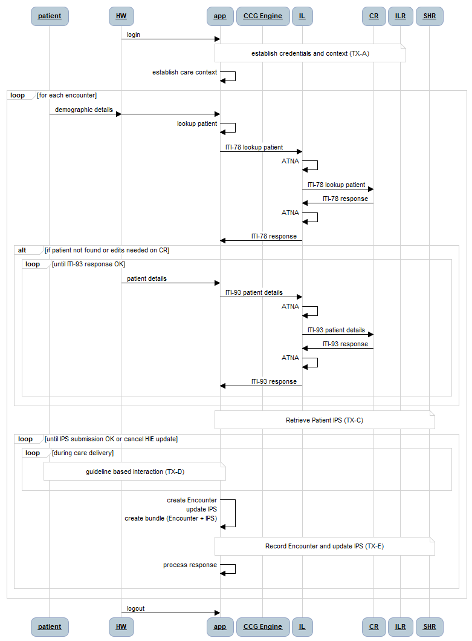

Figure 51 - TX-B: Establish Unique Patient ID

The patient ID resolution transaction (TX-B) is described by the sequence diagram in Figure 51. As illustrated by the diagram, patient demographic information is collected by the health worker (HW) and keyed into the app to execute a local lookup. The demographic information is then used to execute a lookup against the HIE’s client registry (CR). If the patient is not found, or if the local patient data is more up-to-date than the HIE’s demographic data, the app’s local demographic content is persisted to the CR.

### TX-C: Retrieve Patient IPS

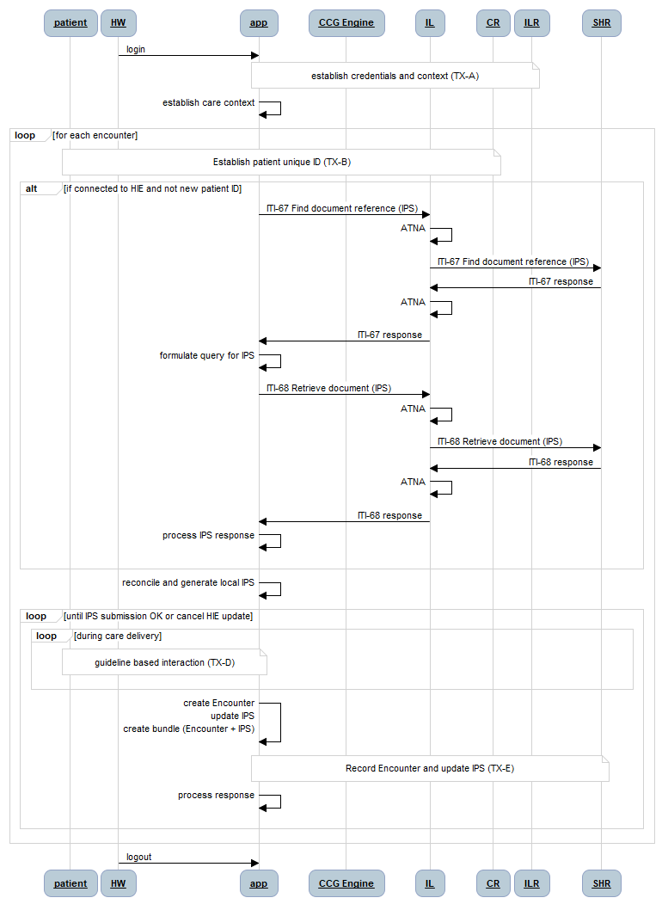

Figure 52 - TX-C: Retrieve Patient IPS

The patient health summary retrieval transaction (TX-C) is described by the sequence diagram in Figure 52. As illustrated by the diagram, following the successful execution of TX-B, a query is made against the app’s local database to retrieve the patient’s health summary. Using the patient’s unique ID, a query is made against the HIE’s shared health record (SHR) repository to find the patient’s most up-to-date International Patient Summary (IPS) document. The document ID for this IPS document is used to retrieve it from the SHR. This IPS is processed by the app, which reconciles it with the local health summary. If the IPS contains information not in the local summary, the local database is updated. If the app’s summary data is a superset of the IPS, then the local copy of the HIE’s IPS document is updated to reflect the more up-to-date content.

### TX-D: Guideline-based care delivery

For the purposes of this demonstration, it is assumed that a computable care guideline (CCG) is developed that reflects national diabetes care guidelines. Notionally, a CCG can be metaphorically thought of as a “folder” full of “cards”. The guideline-based diabetes care recommendations would be contained in a Diabetes folder. Following the analogy, guideline-based antenatal care recommendations would be contained in an ANC folder. Depending on the diagnoses reflected in a patient’s health summary document (their IPS), one or more CCG folders may be applicable to them. Following the present example, a pregnant woman who is under care for diabetes would have both an ANC folder and a Diabetes folder associated with her IPS.

Each guideline-based recommendation for diabetes care can be thought of as being represented by a “card” in the Diabetes “folder”. Every card has three key elements (the **C-A-R**):

1. A “**C**ondition statement” that defines when this card is applicable;
2. A care “**A**ction” instruction that defines what is recommended when the card’s condition statement is evaluated to be TRUE; and
3. An action “**R**esult” that defines what will be documented in the patient’s IPS after the action is taken.

An example illustrates this metaphor. An example country’s Clinical Practice Guidelines for Type 2 Diabetes describes the first-line use of Metformin and second-line use of Sulfonylureas to reduce high glucose levels. Both medications are on the essential drugs list.



Figure 53 - The country’s Type 2 Diabetes Guideline re: Glucose Lowering Agents

A Diabetes folder would contain a card for every recommendation in the National guideline, including routine initial, follow-up and annual visits. An example card for Metformin (the C-A-R) can be narratively described as follows:

**Metformin**

* **C**onditions for applying the card (all must be TRUE):
  + HbA1C > 9% or fasting BSL > 180 or postprandial > 360
  + (Cr < 1.5mg/dL and Sex=Male) OR (Cr < 1.4mg/dL and Sex=Female)
  + Age < 80 years
  + Number diagnosis of heart failure = 0
  + Number diagnosis of hepatic disease = 0
  + Number current findings of high alcohol intake = 0
  + Number existing orders for Metformin = 0
  + The card has not already been “applied” during the present encounter
* **A**ctions to recommend if all Conditions are TRUE:
  + Order Metformin 500mg 2 time daily with meals
* **R**esult of the recommended action having been taken (one of the 2 options):
  + Medication order for Metformin (ATC code A10BA02) dose = 500mg, route = by mouth, timing = 2 times per day (with meals) for 4 weeks, status = active
  + Medication order for Metformin (ATC code A10BA02) dose = 500mg, route = by mouth, timing = 2 times per day (with meals) for 4 weeks, status = cancelled, reasonCode = {select code from list in Figure 54}

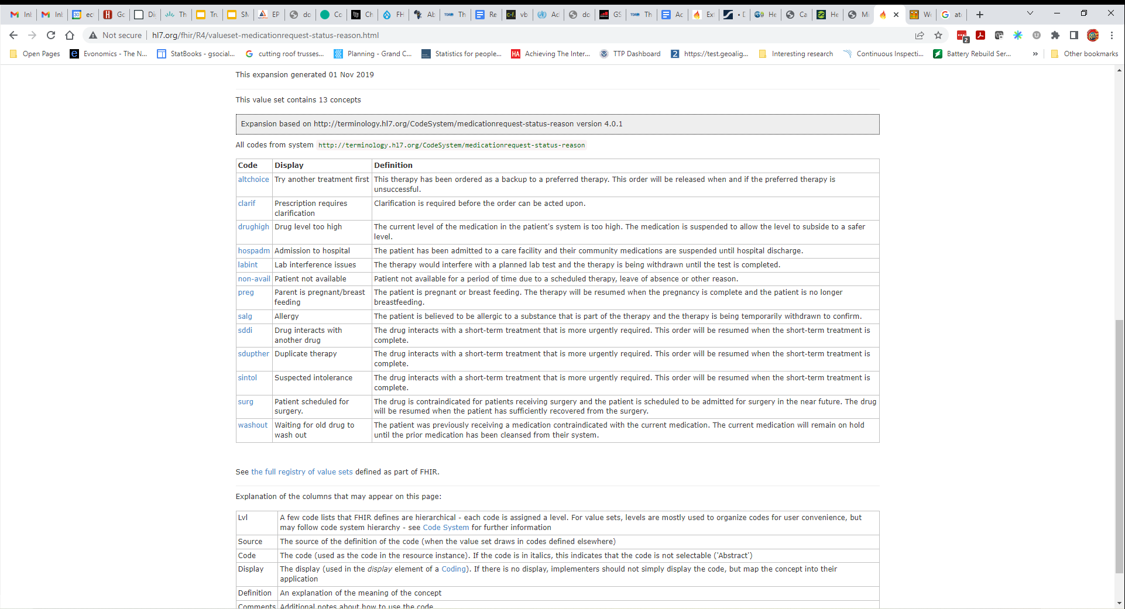

Figure 54 – Normative list of Medication Status Reason Codes

As may be noted from the Metformin example – the logic rules expressed by the C-A-R operationalize the The country care guideline. If the **C**onditions are met, a clinician will be presented with the recommended **A**ction to begin Metformin for their patient. The **R**esult written to the patient’s health summary document will either be an active prescription for Metformin, or a cancelled prescription for Metformin with a reason code indicating why the clinician has foregone the guideline-based recommendation. It should be noted that, if a clinician has foregone the Metformin option, the alternate Sulfonylureas option will be next proposed (defined by a separate card). For patients who are already on Metformin, there will be cards defined that would gradually increase their dosage levels, per the guidelines, until such point as the second line option should be tried (if blood glucose levels were not brought back to target levels).

There are card “types” defined for the tasks that occur during a care encounter. These include medication order cards (as illustrated by the previous example), stop medication cards, cards to record observations (e.g. height, weight, blood pressure, heartrate, etc.), cards to order lab tests (e.g. HbA1C, CBC, x-rays, etc.) or procedures (foot exam, eye exam, etc.), cards to schedule follow-up visits, and cards to augment or escalate care by creating a patient referral. There are also cards to record the actioning of any order (e.g. dispense medications, report lab test results, report procedure results, etc.).

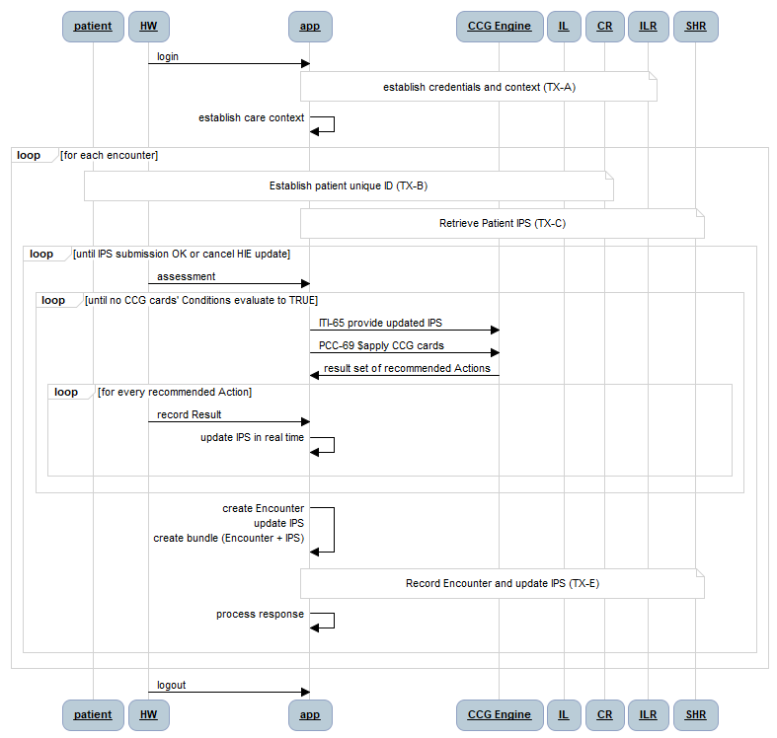

Figure 55 - TX-D: CCG Execution

The patient-safe card processing algorithm (shown in Figure 55) may be described as follows:

* The patient’s health summary is retrieved along with applicable CCG folders in TX-C; if a clinician so chooses, one or more new CCG folders may be associated to the patient during the assessment phase of the encounter
* Iteratively LOOP…
  + The updated patient summary (IPS) is submitted to the CCG engine
  + All the cards from all applicable folders are evaluated based on the current content in the health summary (invoked via a $apply operation submitted to the CCG engine)
  + For every card whose **C**onditions evaluated to TRUE
    - The clinician is shown the recommended **A**ction
    - The clinician has either accepted the recommendation or indicated why it will be followed – and the appropriate **R**esult has been written to the health summary
* …UNTIL no cards evaluate true

### TX-E: Post Encounter details and updated Patient IPS to HIE

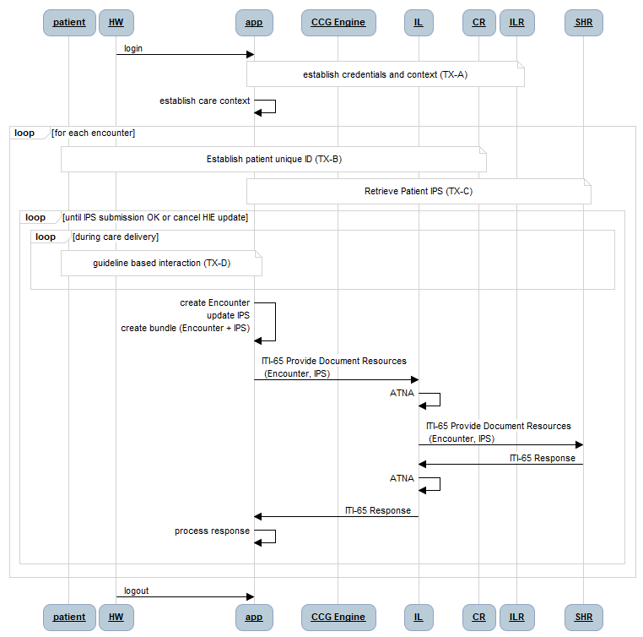

Figure 56 - TX-E: Post Encounter details and updated IPS to HIE

The patient encounter update transaction (TX-E) is illustrated by the sequence diagram in Figure 56. As illustrated by the diagram, following the successful execution of TX-B and TX-C, guideline-based care delivery activities are undertaken as per TX-D. The outcomes of these activities are reflected in an Encounter resource (which faithfully captures the context of the care encounter) plus an updated patient IPS document. The app creates a bundle including the Encounter and the updated patient IPS and persists this bundle to the SHR.

## Demonstrating CCG-based Diabetes Care

A critical slice “demonstration” implementation of diabetes care, adherent to the country’s Clinical Practice Guidelines for Type 2 Diabetes, would require the architectural actors as described in the previous section. This means a simple HIE will need to be operationalized (perhaps leveraging a generic FHIR server plus a SanteMPI instance).

To successfully model the operationalization of CCG-based care workflows, including care escalation, at least two point of service EMR instances are needed. If at least a rudimentary CCG is created, including at least one care escalation “card” (e.g. referral to ophthalmologist), then the managed movement of a patient through the care network can be modeled.

To model care continuity, over time, and across multiple care sites, the following simple scenario may be leveraged:

1. At a primary care facility, onboard a new diabetic patient not found in the CR. Leverage the history, examination, and blood tests outline for an **Initial Visit**. Execute TX-A to TX-E to establish baseline information about the patient, which is saved to the patient’s IPS on the HIE.
2. Subsequently, at the same facility, execute a **Follow-up Visit** for the same patient. Execute TX-A to TX-E. Confirm details from step 1 are available in the patient’s IPS. Update the patient’s phone number. Record readings which establish that blood glucose levels warrant the first-line initiation of Metformin. Order and dispense the Metformin from the facility. Record encounter details in the IPS.
3. Subsequently, at the same facility, execute an **Annual Visit** for the same patient. Confirm the details from visits 1 & 2 are available in the patient’s IPS. Execute TX-A to TX-E. Record results which establish that Metformin has successfully reduced blood glucose levels to within target. Establish a referral to an **ophthalmic specialist** for the annual eye examination.
4. Subsequently, at the ophthalmic specialist’s facility, execute a **Referral Visit**. Confirm the patient’s IPS details reflect steps 1, 2 & 3. Execute the eye examination and record favourable results to the patient IPS.
5. Subsequently, at the primary care facility, execute a **Follow-up Visit**. Confirm the results of the referral are found in the IPS. Execute TX-A to TX-E to record unremarkable results.

This simple scenario:

* Creates a new patient in the CR
* Finds, retrieves, and updates an existing patient’s CR record
* Creates a new patient IPS and saves it to the SHR
* Retrieves a patient’s most recent IPS from the SHR
* Saves an updated IPS to the SHR
* Triggers CCG-based recommendations based on data collected during an encounter
  + Orders and dispenses meds
  + Refers a patient to another care provider

# Appendix 2: 10-year HIE Investment Rationale

*[This appendix will reflect the results of using the HIE Investment Rationale spreadsheet tool to develop and 10-year cost-utility analysis (CUA) for implementing the country’s national HIE. The following section develops an illustrative report of using this tool with country content from Sierra Leone (SL) leveraged as the target country.* ***This is not a work product of the Government of Sierra Leone*** *– it is an illustration only, leveraging example data for that country.]*

This section will describe the assumptions behind a 10-year investment rationale model and report the results of leveraging these assumptions in a digital health investment rationale spreadsheet tool evolved from the one used at the 2017 AeHIN General Meeting in Myanmar.

## Assumptions

### Demographics

As reported in the IHME metrics, the population of AmalgaLand is estimated to be 15.1 million with an anticipated growth rate over the coming 10 years of 2.6% (to 19.5 million).

It will be assumed, for purposes of the model, that the total population of health workers is 20,605[45] and that this population will grow at the same rate as the population growth rate.

### Facilities

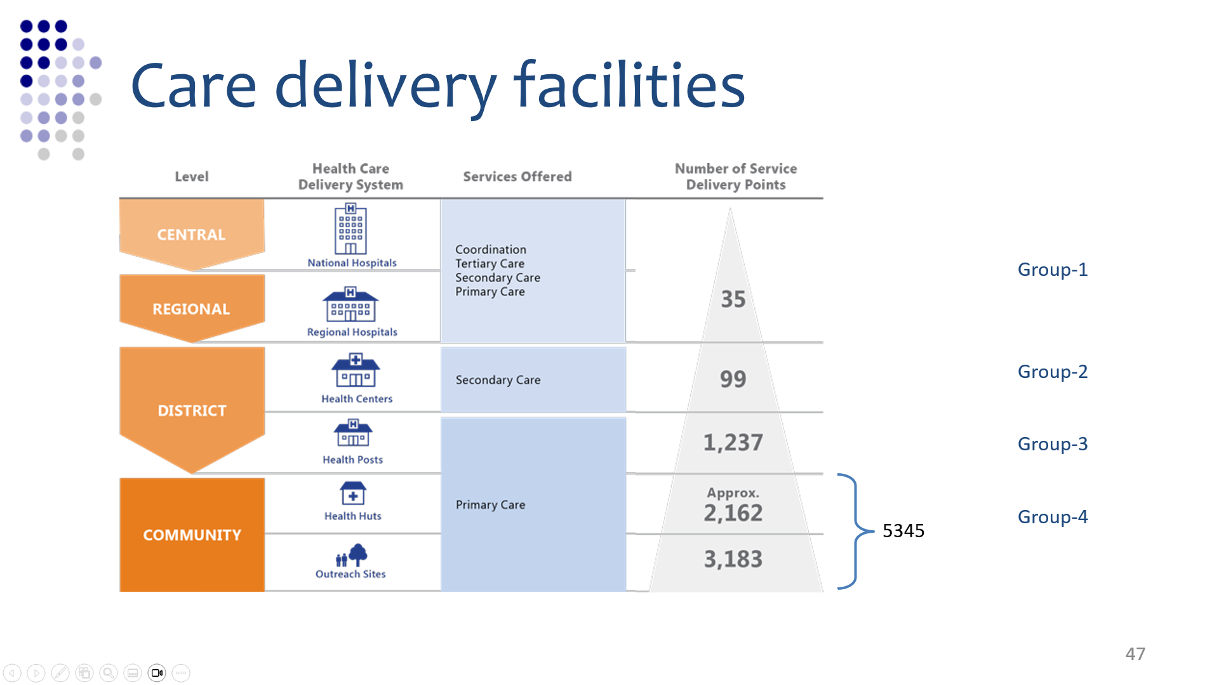

Figure 57 - Facilities and their “cost” categories

It is assumed that digital health will be deployed at all facilities in the Amalgaland care delivery network. To drive the costing model, four different cost categories are assumed:

1. Large-scale digital health implementations with a one-time cost of $50,000 and digital system operating costs of $1000 per month (e.g. implement a cloud hosted solution; provide hardware and training for dozens of digital solution users; sustain hardware maintenance, network access, and local help desk support). For the model, it is assumed National, provincial, and referral hospitals are in this cost category. (est. 35 facilities)
2. Medium-scale implementations with a one-time cost of $10,000 and operating costs of $100 per month (e.g. implement a cloud hosted solution; provide hardware and training for ~10 users; sustain hardware maintenance, network access, and remote help desk support). (est. 99 facilities)
3. Small-scale implementations with a one-time cost of $2000 and monthly operating costs of $100 (e.g. implement a cloud hosted solution; provide hardware and training for ~5 users; sustain hardware maintenance, network access, and remote help desk support). Health centres are assumed to be in this category. (est. 1237 facilities)
4. Remote implementations with a one-time cost of $1000 and monthly operating costs of $25. The 5345 Health Huts and Outreach Sites are in this category.

### Economics

Values from IHME were used to develop the potential DALYs averted by the target interventions of this model.



Figure 58 - Theoretical DALYs from IHME

The disability-adjusted life-years (DALYs) associated with significant causes of death and disability are shown in Figure 58. On a **theoretical** basis, it can be proposed that if 100% of the burden of disease could be alleviated by the application of digital health solutions for Neonatal disorders (#1 in the list), then 889 thousand “life-years” of lost health could be averted.

It is not possible to drive the disease burden to zero using digital health. Even so – sensitivity analysis can be leveraged to answer the question: “how much reduction in disease burden is reasonable to expect from the implementation of digital health – and what are the health impacts, expressed in economic terms, of such a reduction?”

Evaluating the economic value of health impacts is controversial. The long-standing rule of thumb from WHO is that an averted DALY that costs less than 3 annual GDP per capita is a “good buy” and an averted DALY that costs less than 1 annual GDP per capita is a “great buy”. Although this is a much-debated topic – the 1-GDP-per-capita-per-DALY is a simple and widely used heuristic and therefore is leveraged in this model. Also, as a practical matter, it is assumed for the purposes of this model that an averted DALY is *materially equivalent* to a QALY (quality-adjusted life-year) gained.

## Investment Rationale Model (example)

This section describes the values entered into the investment rationale model to develop a first-draft 10-year projection. These values are starting point examples. The relevant fields for each worksheet tab in the spreadsheet are noted in the following sections. NOTE: in the model – the **green** fields are filled in… all others are calculated.

### Summary

The fields data-entered in the Summary tab are shown below.

|  |  |
| --- | --- |
| Year-over-year cost escalation (%) | **9.0%** |
| Annual facility growth rate (%) | **2.5%** |
| Population size (#) | **15,100,000** |
| Annual population growth rate (%) | **2.5%** |
| # Health Workers | **20,605** |
| HW population growth rate (%) | **2.5%** |

|  |  |  |  |  |
| --- | --- | --- | --- | --- |
|  | TYPE 1 | TYPE 2 | TYPE 3 | TYPE 4 |
|  | 0.5% | 1.5% | 18.4% | 79.6% |
| 6,716 | **35** | **99** | **1,237** | **5,345** |

The annual total health expenditure (per capita) is $71.00.

### Governance

The fields data-entered in the Governance tab are shown below.

|  |  |  |  |
| --- | --- | --- | --- |
|  | # | Units | Cost per Unit |
| **Digital Health Strategy** |  |  |  |
| Subject Matter Experts | **40** | days | **$ 1,000** |
| Workshops | **1** | each | **$ 10,000** |
| Regional meetings | **4** | each | **$ 10,000** |
|  |  |  |  |
| **Digital Health Blueprint** |  |  |  |
| Subject Matter Experts | **40** | days | **$ 1,000** |
| Workshops | **2** | each | **$ 10,000** |
| Regional meetings | **0** | each | **$ 10,000** |
|  |  |  |  |
| **eHealth Norms and Standards** |  |  |  |
| Subject Matter Experts | **20** | days | **$ 1,000** |
| Workshops | **1** | each | **$ 10,000** |
| Regional meetings | **4** | each | **$ 10,000** |
|  |  |  |  |
| **Health Data Sharing Policy** |  |  |  |
| Subject Matter Experts | **10** | days | **$ 1,000** |
| Workshops | **1** | each | **$ 10,000** |
| Regional meetings | **4** | each | **$ 10,000** |
|  |  |  |  |
| **Digital Health Governance** |  |  | **Annual cost/unit** |
| Committees | **1** | department | **$ 100,000** |
| Regular meetings | **50** | meetings | **$ 100** |
| National meetings | **4** | meetings | **$ 15,000** |

The assumptions regarding the strategy, blueprint, standards, and policy activities is that there is a consensus-building effort that may require outside TA. It is further assumed that these artefacts will be required pre-launch, and will be refreshed in year 5 and again in year 10 of the 10-year plan (and that the costs will be appropriately adjusted for inflation in these future years).

The last cost category, Governance, is assumed to be ongoing through every year of the 10-year plan with appropriate accommodation for inflation. This is the sustaining cost for operating a secretariat within a Digital Health Department plus the costs of the PMO and conformance testing services that this group will be responsible for.

### Datacentre

A simplified assumption was made regarding MOH procurement of infrastructure as a service (IaaS). The setup cost was budgeted at $500,000 and the monthly operating fee was budgeted at $20,000.

### CR (client registry)

For this tab, simple assumptions were made related to the cost per ID card (e.g. a simple paper or cardboard card that can be printed at a facility in real time). It was also assumed that these would have a 5-year validity period and that 1% of cards will need to be reprinted each year because they are lost or damaged. Every chiefdom and hospital health facility is assumed to be able to issue cards (facilities of type I and II). The setup cost for each facility (e.g. card printer) is expected to be $200 and a $50 monthly budget is set for consumables and maintenance.

Digital ID provisioning costs were assumed to be negligible ($0.01 for each ID). It was assumed that 100% of the population will require a digital ID and a wallet ID.

|  |  |
| --- | --- |
| Digital ID provisioning cost ($/ea) | **$ 0.01** |
| ID card provisioning cost ($/ea) | **$ 0.05** |
| ID card renewal period (yrs) | **5** |
| ID card churn rate (%/yr) | **1.00%** |
| ID issuing facilities (#) | **1,371** |
| ID establishment setup cost ($) | **$ 200** |
| ID establishment operating cost ($/mo.) | **$ 50** |
| Initial proportion that need digital IDs (%) | **100%** |
| Proportion that need cards (%) | **100%** |

### ILR-FR (Interlinked Facility Registry)

The costs for the ILR-FR are driven by the number of underlying data sources, the cost to connect each data source to the ILR (and to maintain this interface) and by the number of interactions the MoHS will need to have with **each facility, each year** in order to ensure the data is kept current and correct. The cost per interaction will vary depending on whether it is an in-person visit or a phone call. An average cost of $5 per “check” is assumed.

|  |  |
| --- | --- |
| Facility databases (#) | **2** |
| Cost per database application interface ($) | **$ 10,000** |
| API maintenance cost per year (%) | **15%** |
| MOH interactions per facility per year (#) | **2** |
| Cost per interaction ($) | **$ 5.00** |

### ILR-HWR (Interlinked Health Worker Registry)

The cost drivers for the ILR-HWR are identical to the ones for the ILR-FR, with the exception that MoHS interactions to ensure data correctness involve data checks with health workers vs with facility operators. The idea is that a text message or automated phone message solution could be employed to confirm details with each health worker at least once per month. The estimated cost reflects connecting 4 underlying databases (e.g. from Colleges or Professional Associations, MoHS HR systems, etc.) plus the use of simple SMS message exchanges.

|  |  |
| --- | --- |
| Health Worker Cadre databases (#) | **4** |
| Cost per database application interface ($) | **$ 10,000** |
| API maintenance cost per year (%) | **15%** |
| MOH interactions per HW per year (#) | **12** |
| Cost per interaction ($) | **$ 1.00** |

### SHR (Shared Health Record repository)

The cost drivers for the SHR are not as much related to the central server as they are related to the point of service (POS) applications that must be implemented at facilities and connected to the HIE. Here, the assumptions (denoted in the previous section) for implementation costs for each of the 3 different facility types drive the model. Also, it is assumed that each different POS application will need to be interfaced to the SHR and the costs of these interfaces will need to be maintained.

|  |  |
| --- | --- |
| Unique health ICT applications (#) | **10** |
| Cost per application interface ($) | **$ 25,000** |
| API maintenance cost per year (%) | **15%** |

For the deployments to facilities, an estimate is made of the implementation cost plus the annual operating costs. To model the timing, an estimate is made of the number of facilities that already *have* solutions implemented, plus the number of years that will be needed to complete deployment to all facilities. There is an expected requirement that the MOH will interact with each facility to audit conformance or to refresh software or other tasks – and these costs are estimated by annual number of interactions and cost per interaction.

To be conservative, it is assumed zero facilities are HIE-ready, today and that MOH is responsible for the deployment costs at 100% of the facilities.

|  |  |  |  |  |
| --- | --- | --- | --- | --- |
| **Facilities (from Summary sheet) (#)** | **TYPE 1** | **TYPE 2** | **TYPE 3** | **TYPE 4** |
| Facilities of this TYPE (#) | **35** | **99** | **1,237** | **5,345** |
| Facilities MOH pays for (%) | **100%** | **100%** | **100%** | **100%** |
| MOH-supported facilities (#) | **35** | **99** | **1,237** | **5,345** |
| 1-time implementation cost | **50,000** | **10,000** | **2,000** | **1,000** |
| Annual ICT operating cost | **12,000** | **1,200** | **1,200** | **300** |
| Current ICT adoption (%) | **0%** | **0%** | **0%** | **0%** |
| ICT rollout period (yrs) | **2** | **4** | **4** | **4** |
| MOH interactions per year | **1** | **1** | **1** | **4** |
| MOH cost per interaction | **200** | **100** | **50** | **5** |

### TS (Terminology Service)

The costs for the terminology service are driven by the number of underlying code lists that have to be licensed plus the annual maintenance fees per year for these licenses. For SL, it is expected that open standards will be leveraged so these costs are omitted. The other cost driver is the number of times the code lists must be refreshed by the POS applications and the cost of each refresh.

|  |  |
| --- | --- |
| Total cost of codelist databases ($) | **$ 250,000.00** |
| Codelist maintenance cost per year (%) | **15%** |
| # of software applications (from SHR sheet) | **10** |
| MOH interactions per app per year (#) | **4** |
| Cost per interaction ($) | **$ 1,000.00** |

### HMIS (Health Management Information System)

The HMIS costs are driven by the number of data warehouses, the cost for an SHR-HMIS data interface, and the annual maintenance costs for each interface. Operational costs are also driven by the number of data collections per year and by the cost of each of these data reporting workflows.

|  |  |
| --- | --- |
| HMIS databases (#) | **2** |
| Cost per SHR-HMIS interface ($) | **$ 25,000** |
| API maintenance cost per year (%) | **15%** |
| **# Facilities (from ILR-FR sheet)** | **6,716** |
| Annual growth rate (from ILR-FR sheet) | **2.5%** |
| HMIS data collections per facility per year (#) | **12** |
| Cost per interaction ($) | **$ 10.00** |

### HRH Capacity

It is assumed that education will be provided to each health worker regarding data use. This education will be provided at the outset of the HIE programme and a refresher will be provided every year. It is also planned that degree-granting programmes will be established at Amalgaland’s two largest universities. These academic programmes will be set up in year 1 and year 2 of the 10-year plan. Each programme has a 1-time setup cost plus an annual operating cost (in excess of what is recovered through student fees).

|  |  |
| --- | --- |
| Initial cost: HW education in data use ($/HW) | **$ 250.00** |
| Annual refresher cost: HW education in data use ($/HW) | **$ 10.00** |
| Setup cost: academic HI programme ($/institution) | **$ 500,000.00** |
| Annual cost (net): academic HI programme ($/institution) | **$ 100,000.00** |

### CUA (Cost Utility Analysis)

The CUA is a cost-effectiveness analysis. For this reason, the calculated 10-year costs based on the preceding assumptions are compared against the 10-year health benefits that can be expected to accrue from broadly deploying digital health in support of guideline-based care and care continuity.

The cost-effectiveness threshold for Amalgaland is **$1600**, which represents a CET of 1 GDP per capita.

As described in the previous section, a cost-effectiveness threshold (CET) is determined to be 1 annual GDP per capita (a “great buy”, based on the simple WHO heuristic). Also leveraging the section on **Error! Reference source not found.**, the following 4 targeted diseases are identified as those amenable to being impacted by improvements in guideline adherence and care continuity.



For each target, the total health impact is identified, expressed as QALYs (which for this analysis are assumed to be equal to averted DALYs). The time to benefit, in years, is indicated for each. This is noting that benefits may not be realized until, for example, all of the health facilities have completed their digital health implementations. To support sensitivity analysis, a benefit realization value (expressed as a percent) is used to calculate how much of the total disease burden can be ameliorated through the digital health intervention. It is an underlying assumption that the impact of digital health will be to operationalize guideline-based care – and in this way, the health impacts could be dramatic. Even so, conservative benefit values of 1%, 2% and 5% were used to determine the cost effectiveness curves over the 10-year model horizon. NOTE: based on the assumptions listed in the previous sections, the CUA is net positive (e.g. QALY value is greater than the CET) at even a 1% benefits realization.

## Results

Based on the assumptions in the model, the following results may be reported.



Figure 59 - Cost-effectiveness over 10-year Horizon (1% health benefits Impact)

Assuming digital health interventions making a 1% impact on addressing 5 disease burdens (Malaria, Ischemic Heart Disease, Neonatal Disorders, Diarrheal Diseases, and Lower Respiratory Infections), with a 4-year term before realizing benefits, it is modeled that a national-scale digital health investment across all facilities would achieve cost-effectiveness after 6 years. The 10-year investment model is shown in Figure 59.



Figure 60 - 10-year Investment Model (Summary)



Figure 61 - 10-year Benefits Model (1% benefits realization)

## Discussion

The investment rationale spreadsheet tool is expected to be leveraged to support top-level planning. It may be leveraged to develop and evaluate scenarios and their impacts. The model results reported here are sensitive to the underlying assumptions, including a key assumption that digital health will impact health outcomes by improving adherence to care guidelines and care continuity and, hence, care quality.

The following may be noted from this model analysis:

* Over a 10-year model period, the assumed investment and operating plan would require total digital health budget of **approximately $136 million**. The annual digital health budget represents an increase of **approximately 0.85% of total health expenditure**.
* The model conservatively assumes that digital health investments are “starting from zero”. Where this is not the case, the time to realize benefits may be accelerated.
* A platform approach is recommended that could be employed to operationalize guideline-based care for **any** disease. This is in contrast with siloed investment in treating particular diseases or in providing services only for particular groups of patients.
* Using the burden of disease across only 5 conditions, and assuming guideline-based care operationalized through digital health would have only a 1% impact on this burden, and further assuming a 4-year implementation period during which zero benefits will accrue, the modeled investment plan is cost-effective by year 6. This scenario assumes **all** the cumulative costs, from **inception**, are “recovered” by the health benefits realization by year 6.
* By year 10, the digital health investments are returning **$1.80 per dollar** (assuming the 1% impact and 4-year implementation period).
* If a **5% impact** is achieved, the investment is cost-effective in year-4 and the **10-year ROI is $9.00 per dollar**.

1. [https://www.healthdata.org](https://www.healthdata.org/cambodia)
2. <https://ghdx.healthdata.org/countries>
3. <https://monitor.digitalhealthmonitor.org/map>
4. <https://apps.who.int/iris/handle/10665/75211>
5. <https://guides.ohie.org/arch-spec/architecture-specification/overview-of-the-architecture>
6. <https://wiki.ihe.net/index.php/Mobile_Health_Document_Sharing_(MHDS)>
7. <http://hl7.org/fhir/uv/ips/>
8. Mandatory data (R) must be included in the IPS document. Required “if known” (S) data *may* be blank, but if it **is available**, it must be included in the IPS document.
9. <https://www.snomed.org/international-patient-summary-terminology>
10. <https://www.whocc.no/atc_ddd_index/>
11. <https://loinc.org/>
12. <https://www.snomed.org/international-patient-summary-terminology>
13. <https://www.whocc.no/atc_ddd_index/>
14. <https://loinc.org/>
15. <https://profiles.ihe.net/ITI/SVCM/index.html>
16. <https://www.who.int/data/data-collection-tools/harmonized-health-facility-assessment/introduction>
17. <https://profiles.ihe.net/ITI/PMIR/index.html>
18. <http://build.fhir.org/ig/HL7/fhir-ips/StructureDefinition-Patient-uv-ips.html>
19. <https://profiles.ihe.net/ITI/MHDS/volume-1.html#1501-mhds-actors-transactions-and-content-modules>
20. An example could be the HAPI FHIR server: <https://hapifhir.io/>
21. <https://profiles.ihe.net/ITI/mCSD/>
22. <https://www.who.int/publications/i/item/harmonized-health-facility-assessment-(hhfa)>
23. <https://profiles.ihe.net/ITI/mCSD/index.html>
24. <https://www.ihris.org/>
25. <https://cdn.who.int/media/docs/default-source/health-workforce/dek/classifying-health-workers.pdf?sfvrsn=7b7a472d_3&download=true>
26. <https://build.fhir.org/ig/HL7/fhir-ips/OperationDefinition-summary.html>
27. <https://ips.health/>
28. <https://gdhp.health/>
29. The IHE MHDS profile describes the overall operations of the HIE, including the support for health document exchange. The SHR’s behaviours are described within this overall context, here: <https://wiki.ihe.net/index.php/Mobile_Health_Document_Sharing_(MHDS)>
30. <https://profiles.ihe.net/ITI/MHDS/>
31. <https://ihe.net/uploadedFiles/Documents/QRPH/IHE_QRPH_Suppl_ADX.pdf>
32. <https://gazelle.ihe.net/category/default/ihe>
33. <https://profiles.ihe.net/ITI/mCSD/index.html>
34. Ad hoc care is care that is **not** following a pre-defined guideline. This ***may*** be emergency care; however, this is not true in all cases that emergency care is ad hoc. Sometimes, emergency care may also be guideline-driven (head trauma, for example).
35. It is not expected, necessarily, that all POS solutions will be employed to onboard new client demographic records to the national CR. This may be a centralized administrative process that includes generating a unique ID card, for example. Or there may be a dedicated CR* POS app that all care sites are required to use, external to the digital health solution.
36. <https://www.ontario.ca/laws/statute/04p03>
37. <https://www.ihis.com.sg/nehr/faqs>
38. <https://www.researchgate.net/publication/332530889_Digital_Health_Data_and_Information_Sharing_A_New_Frontier_for_Health_Care_Competition>
39. <https://www.cpso.on.ca/Physicians/Policies-Guidance/Policies/Medical-Records-Management>
40. <https://health.gov.on.ca/en/pro/programs/connectedcare/oht/docs/dig_health_playbook_en.pdf>
41. <https://www.cms.gov/newsroom/fact-sheets/interoperability-and-patient-access-fact-sheet>
42. <https://www.eu-patient.eu/globalassets/policy/data-protection/data-protection-guide-for-patients-organisations.pdf>
43. <https://www.oecd.org/dac/effectiveness/45827300.pdf>
44. <https://www.gsma.com/mobilefordevelopment/resources/webinar-on-demand-digital-health-a-tool-for-building-resilient-health-systems-in-a-covid-19-world/>
45. This was ballpark estimated using 50 HR per type-1 facility, 20 per type-2, 5 per type-3 and 2 per type-4.